ACAS
Applewood Computers Accounting System

Incomplete Records System
and General / Nominal Ledgers

Reference Manual

v3.3

This document is the Reference manual for IRS
Applewood Computers Incomplete Records System which is, in turn is part of ACAS
(Applewood Computers Accounting System) and is
Copyright © Applewood Computers and Vincent B Coen 1980 - 2025 and later.

Which Includes :
*IRS – Incomplete Records System (used in place of GL) if needed
*Sales Ledger also known as Accounts Receivable
*Purchase Ledger also known as Accounts Payable
*Invoicing (module/s added into Sales Ledger & Purchase Ledger)
*Stock Control (also known as Inventory) with links to Sales & Purchase
*Nominal Ledger and referred to as GL (General Ledger)**

Items identified by a star (*) are now Open Source packages.
This and the accompanying documents relate, to these Open Source packages.

Each sub system has its own documentation.

Applewood Computers
17 Stag Green Avenue
Hatfield
Hertfordshire
AL9 5EB
United Kingdom

Lead Programmer Email: vbcoen@gmail.com
For Technical Support Contracts contact: Same as above

Support Email: vbcoen@gmail.com
Website: www.sourceforge.net/p/acas

Author: Vincent Coen, The author asserts his copyright over this work.
Document update: 18. September 2025 23:18:26
Revision: 101
Software Version Date: 18 September 2025 and nightly builds
Software Version 3.3 and for v3.2.
Word Processor: LibreOffice 7.5

1 3 5 7 9 0 2 4 6 8

Table of Contents
1 System Overview 5
1.1 Introduction 5
1.2 Support and problem reporting. 10
2 The physical structure of IRS 11
2.1 Files used by the system 11
2.2 IRS Programs 13
2.3 Processing Flow 15
2.4 Program File Usage 17
3 General Information 18
3.1 The importance of backup 18
3.2 Backup Recovery 20
3.3 A Glimpse at double entry book keeping and the detection of errors 22
4 System Set-up & Maintenance 26
4.1 The system menu - IRS 26
5 Chart of Accounts Set-up & Maintenance 28
5.1 Account Overview 28
5.2 Set-up Chart of Accounts 31
5.3 Amend the Chart of Accounts 33
5.3.1 Amendments 33
5.3.2 Addition 33
5.3.3 Deletion 33
5.3.4 Print the Chart of Accounts 33
5.3.5 Display the Chart of Accounts 34
5.3.6 Export the Chart 34
5.3.7 Import the Chart 35
5.3.8 Return to System Menu 35
6 Default Accounts Set-up & Maintenance 36
6.1 Default Accounts - IRS020 36
6.1.1 An Account Number 36
6.1.2 The Transaction Code 36
6.1.3 The VAT type 36
6.2 Set-up Default Accounts 38
6.2.1 VAT Accounts and Defaults 38
6.2.2 Suspense Account 38
6.3 Amend Default Accounts 40
6.4 Display Default Accounts 41
6.5 Print the Defaults 41
6.6 Set-up Final Accounts 42
7 Posting – IRS030 44
7.1 Enter run option 44
7.2 Enter Default Number 45
7.3 Correct Account (Y/N) 45
7.4 Enter Run Characteristics (DR) or (CR) 45
8 Trial Balance - IRS040 48
9 The Audit Trail - IRS050 49
10 The Final Accounts - IRS060 50
11 Amend Postings - IRS070 52
12 Nominal File Fix up - IRS080 53
13 Analysis Report - IRS090 54
14 ACAS System wide File and RDBMS Table Usage Chart 55
15 Reporting problems with ACAS products 57
16 Error messages used within the ACAS system 58
16.1 Cobol and C Error Messages 58
16.2 ACAS Error Messages 58
16.3 SSDs and Garbage Collection. 59
16.4 ACAS System wide Messages 61
16.4.1 From FH (the Cobol File Handlers) 62
16.4.2 From DAL (the RDBMS Data Access Layer) 62
16.4.3 From FH-and DAL Logger (During Testing only) 62
16.5 System wide Messages for IRS 64
16.5.1 IRS System wide FH (File Handlers) 64
16.5.2 System wide DAL (RDBMS Data Access Layer) 64
16.5.3 Specific Messages by Program or Module 65
16.6 File Access Error numbers 69
16.7 RDBMS error codes 70
16.8 MySQL SQL Status messages 70
17 Error Recovery 71
18 Scripts 72
18.1 acasbkup.sh 72
18.2 acasbkup-Pre-EOY.sh 73
18.3 acasbkup-Post-EOY.sh 74
18.4 Dykegrove.sh 75
19 Update or Conversion programs – acasconvert etc 76
20 IRS Set-up 77
20.1 IRS Executable Programs 77
20.2 IRS Source Programs 79
20.3 GnuCOBOL Compiler v3.2 or later 81
20.4 Running IRS and its requirements 82
21 ACAS Parameter Entry and Maintenance 83
22 Sample Charts of Account 84
22.1 Limited Company 84
23 Posting Methods 87
24 Introduction to Double Entry Book Keeping 88
24.1 Double entry book keeping as applied to IRS. 88

System Overview

Introduction

For 'the I want to get it going now people', don't, read the manual in full.

Before getting in to it, a word or two on the usage of the various options of storing the data used within ACAS and here, specifically IRS.

There are two forms or formats for the storing of data namely:
1. Using files.
2 Using database tables through the usage of a rdbms (Relational Database
Management System) – currently only MySQL and Mariadb as these have free to
use versions called community editions.
Others can be added subject to users requests.

If you are going to use one or more sub systems within the ACAS suite that will result in more than one user using the system at any one time then the use of databases will help prevent any issues with users requiring access to the same data at any one time where the data could or will be changed.

In theory using files can work and in this example practical usage shows that problems will occur, i.e., lost data or delays in accessing data currently being used by another user. This does depend on the file engine being used (i.e., BDB, VBisam etc) to some extent but most will have the issue one way or another.
The use of rdbms databases help prevents this, as that is what they are designed for, allowing many users to use the system at the same time.

If however ACAS will only be used by one user or one at a time ever, than using files will be fine but this really applies to very small (or start up) businesses and anything larger may well require database usage as more than one user will be using a specific sub-system (such as IRS, Sales, Purchase, Stock, etc.) at the same time.

The amount of time required to set up the rdbms system on one or more computers (where they are set up to run in parallel only) is far outweighed by the efficiency of their use.

When using the files option it is a straight forward procedure to convert over to using rdbms by the use of the supplied data load programs that will transfer all data held on all files over to the correct rdbms tables and this involves running a automated process once the database has been set up having made some changes to the ACAS parameters to support database tables.

The Incomplete Records System (IRS) was originally designed as a tool to be used by an accountant or book keeper to aid them in the production of a set of accounts for a company or business where a full set of paper books have not been kept and where a client has provided the accountant with boxes containing bundles of bank statements, cheque stubs (if used) for each bank account, all sales invoices & receipts and again purchase invoices & receipts etc. This is often referred to brown bag (or brown box) accounting. They can then, be input into IRS in batches of work e.g., all bank statements together, all purchase invoices and all sales invoices. This speeds up the work flow where on behalf of many small businesses, the whole process can easily be done within a day and often considerably less. The same applies to businesses who input the data daily, weekly or monthly using their bank statements and receipts, etc and produce reports on the current state of their business.

When using the full ACAS system automated postings occur by each sub system such as Sales, Purchase, Stock as needed during the processing cycle so that actual manual data entry into IRS is kept to a minimum.

IRS is, in every respect a Nominal / General Ledger system for the use of any business or company.

Now both book-keepers and accountants can work for more than one client so the process to deal with them is a little more involved but fairly straight forwards in that each type of client should be initially created in their own directory but with no data created other than the system file, analysis file and the CoA (Chart of Accounts) and these should be placed in separate directories for each client type such as Limited, Sole trader, Partnership, Charities etc.

With that done, a copy of the specific client type can be copied over to a new directory for that client say by name below the primary ACAS directory. This way you only have to create these CoA files once and then only need to go in to the parameter system file set up making very small changes for that client such as the name and address and start and end account period dates. Here help is provided in IRS menu 2 - Account Setup & Maintenance then options 6 - Import the Chart and 5 - Export the Chart. These will allow for the transfer from and to respectively of a text file holding a set of accounts for a client type, In this way only minor changes will be needed for a specific business.

Also a script for running that specific clients data should be set up to minimise any risk of error because of attempting to use the wrong clients data and here see the example of one called Dykegrove.sh (which is also supplied as dykegrove.sh), see the scripts in chapter 18 showing the example. .Note that these start running from the top most level ACAS directory which in turn provides a menu option of going into the required system.

Final accounts printed and/or transferred to the online filing systems for Companies House and/or HMRC (for UK companies) can all be completed in under a working day and usually less than four hours. As such, it provides the maximum flexibility consistent with ease of use. The facilities provided are those required to complete a job from its source documents through to the final accounts.

Many companies use IRS in place of General / Nominal Ledger, where the need to keeping track of accounts for MPC (Multiple Profit Centres) or Branches is not wanted or too complex to use where the requirement is, for the recording of financial accounting transactions for the purpose of producing VAT Returns, periodic and year-end financial accounts and keeping track of your debtors and creditors and cash and bank balances on a day to day basis.

In addition, it has been kept as simple as possible so that any business may use it in their day to day operations and also in conjunction with the ACAS ledger systems, e.g., Sales, Purchase and Stock Control, etc.

It has been designed to be run on any computer platform that the GnuCOBOL (TM) compiler can be run on, which includes Linux, BSD, Unix, Windows, Mac, Mini's and Mainframes running Linux, all of which need to have installed the development tools including GNU gcc compiler suite as well as GnuCOBOL and any other tools that it requires. Many of the Linux distros (distributions) have most of these tools already installed or available on the DVD or via the Linux distros repos (repositories) using an internet connection, that makes up the distribution although not all of them have the latest version of GnuCOBOL available so it is always worthwhile to check on the sourceforge website at http://sourceforge.net/projects/gnucobol to see what the current version is.

The remainder can be easily obtained via the internet. See chapter 20.3 (and see the manual ACAS – Building the ACAS System) for more information on setting up IRS and the tools needed to get it working along with the rest of the ACAS system.

Other compiler's can and will present problems due to lack of functionality regarding 2002, 2014 and the other later Cobol standards. Versions for the use of other branded compilers may well also be available such as for Micro Focus Visual Cobol, Net Express etc. However they may not be the most current available so contact us for details.
Out of the above list of Cobol compilers only GnuCOBOL is free to obtain and use on as many computer as you wish, and all the rest are expensive per computer and are in the region of 5 - 6,000+ for each one per installed computer.

The IRS facilities can be split into three distinct groups:-
- Environmental - Those facilities which are used to describe the job to IRS as well as the rest of ACAS. This includes the CoA (Chart of Accounts).
- Posting - The entry and maintenance of transactions
- Reporting - Trial Balance, Audit Trail, Final Accounts, etc.

Other features of the system include:-
- Main and sub-nominal accounts.
- Interactive menu-driven programs.
- Automatic postings to contra accounts (double entry book keeping).
- Report displays and printing.
- Automatic calculation of VAT with manual override.
VAT day book.
- Support for amounts up to 9 millions for entries and 99 millions for totals.

The package has been designed by Accountants with considerable experience of the requirements of small and medium-sized businesses with expertise of computer and their usage to aid their working practices. The original version of IRS was written in Basic and re-coded to Cobol in the late 70's where the basic version was retained and sold to accountants and their customers where later versions also acted in a small way as a Sales and Purchase ledger as well although, with some limitations.
Another reason for the creation of ACAS.

The records in such businesses are often maintained by the Proprietors, who may have had little or no previous book keeping or accountancy tuition or experience. Very often the records are kept solely for presentation to the HMRC (UK) for VAT and to their accountants for the production of year-end Accounts to submit to the Inspector of Taxes but by looking at the various reports available in IRS the business owner can see what their liabilities for such are, at any time and not have to wait for the accountant to finalise the business accounts.

It is intended that the use of this package will not only perform the aforementioned functions but that it will save you considerable time, result in a greater degree of accuracy and will also provide you with vital financial management information which may not previously have been available to you.

Those who have previously maintained manual accounting records will be more than aware of the difficulty of extracting up to date information. Such information is not only essential to most businesses to enable efficient financial management but is also being demanded by banks and other external financial backers.

Very many businesses suffer with cash flow problems. It is not suggested that the use of this software along with the other elements that make up ACAS will necessarily solve those problems but it will certainly enable a greater awareness of the financial position of the business and will facilitate forward planning of the cash position. Such forward planning will allow the early prediction of an impending cash crisis and will thus allow more time for the appropriate remedial action.

IRS has been in daily use by different types of businesses for over 40 years. During this period the software has been periodically improved and expanded.

The software was originally written for use by a firm of practising accountants in the preparation of accounts and in carrying out book keeping for their many clients as well as use by their client businesses that at the end of the year supplied them with the created data files on a USB memory stick, or a CD or via an email as file attachments or as time has gone by on floppy disks but there again, some computer users still use floppy disks.

The other elements in the ACAS software suite consists of :

Stock Control or Inventory, supports the Sales Ledger system in providing accurate invoicing against known stock levels as well as statistical analysis of products or services sold. Stock is maintained directly through the Purchase Ledger or with Stock Control with the manual entering of stock arriving at the warehouse or other locations using both the packing note or invoices against item actually received. Additional reports are available to show which stock is at or below the minimum required on a per product item level at any time.

Sales Ledger or Accounts Receivables, is essential for the use of Sales Invoicing. Sales Ledger will enable the automatic production of Invoicing, Packing Notes, Statements for customers, Aged Debtors report and the allocation of monies against specific invoices.

Purchase Ledger or Accounts Payable, enables the automatic production of remittance advices, an Aged Creditors report and the allocation of monies paid against specific invoices.

Every computer user will appreciate that all computer software can always be improved and often needs to be updated to take advantage of the improved facilities available on the latest computers.

IRS, as has the rest of ACAS, been undergoing constant revision which has resulted in the latest release being considerably faster and with many additional features.

This process is intended to continue indefinitely as appropriate user suggestions are incorporated. Those users who have an ACAS or IRS maintenance contract will automatically receive each update via (attached) email or to download via our websites.

All suggestions for improvement will be gratefully received and acknowledged.

This version of the manual has been modified for the Open Source version which uses the GnuCOBOL compiler and some functionality (e.g., usage of extra search facilities via the F3 key) may have been removed mostly due to missing functionality within the compiler but which forms part of the commercial version that is offered for those users that require support and/or maintenance during their usage of ACAS or specifically IRS.

Note However, that a yearly maintenance and support contract is available of the Open Source versions of the ACAS suite as well, but is not required as updates are offered to all users.

Support and problem reporting.

Free support for the open source version is also available.

For extra details, refer to the contact information inside the front cover of this document for access to a company representative in support of this product.

If you find any errors or missing topics etc., please report them using the contact details shown on inside front cover of this manual or via the website bug reporting feature along with the manual and software versions in use.

Do not “assume” that it has been previously reported. Not everyone will spot it.

The same applies, if you think you have found a bug in the software e.g., where a program or process is not doing what you think it should or in relation to what is specified in the manual but please be aware that many problems relate to using the system in a directory that has:

- Enough unused disk space and usually over 10% of the total for the hard drive & partition.
- Correct access controls for the directory you are using e.g., you own it or that you have full access permissions.

Note That you should never use a Linux, OSX (or for that matter Windows) system as root or administrator for other than to administer the system and never; to run any application as security will be seriously compromised, e.g., open to attack from the inside and outside.

This cannot be said often enough, so do not do it.

The physical structure of IRS

Files used by the system

This section briefly describes the files used by IRS where the usage of rdbms database tables is not used. Although not necessary for the use of the system, an insight into the way IRS works may prove invaluable should any problems occur. IRS stores all the data relating to a particular job and business in only five primary files. These files are described below.

The program names shown here and in 2.2 are all in upper case for ease of reading, but they are in fact, supplied and used in lower case, e.g., IRS010 is supplied as irs010 and are in no way modified by use.
All files are in lower case as shown. To use the system you do not need to remember the program names as all operations is done through a menu system.

The System File - system.dat

Contains user and client information. It also holds the current date, the VAT rate, and the next posting number as well as other system information for all other elements of the ACAS system. Note that this is a change from earlier versions of the system and now all data files used for all of ACAS are held in the one directory. For ACAS users that use rdbms (Relational Database Management System) the only file that will still exist and be used is the ACAS system parameter file.
If using IRS for more than one business, a separate directory holding the system file must be created for each, even if using the rdbms database system and here you would use a different database name for each business and it is suggested using the client name with say ‘DB’ following. For example for client Dykegrove use the database name DYKEGROVEDB etc.

The Chart of Accounts File - irsacnts.dat

This file contains the records of each nominal and sub nominal ledger account.
This consists of the account number and type, its name and the two current balances - one for credit and one for debit plus the cumulative totals.

The Defaults File - irsdflt.dat

This file contains information about contra-accounts. It is used when posting transactions to the Nominal Ledger so that double entry processing can be maintained in a easy to use manner.

The Postings File - irspost.dat

Holds one record for each posting made. This record contains the debit and credit accounts, the net amount and the VAT / Tax amount and type. It is maintained throughout the financial year and is cleared down once all needed reports have been produced.

The Final Accounts File - irsfinal.dat

Contains the descriptions to be printed at the end of each account group on the Profit and Loss Report and the Balance Sheet. This is only needed if the Final Accounts report headings taken from the accounts need to be substituted such as when used outside the United Kingdom or as a special case.

This is normally, not needed and therefore not generally used but some accountants might request it.

IRS Programs

On displays and most reports, the program/module name along with its version number is always shown. This helps in providing support in the rare case of suspecting a program fault (bug). The name and version number as well as the operating system used, must always be given along with any fault found. Do not assume that the fault has been previously reported. Updates of any fixes are always made available for users of the various systems that Applewood Computers provide via our own and the sourceforge websites.

IRS - Main Menu

This is the tool to allow you to select the specific function you require by displaying the main menu so that the user may select which facility is required.

IRS000 – Date Entry for today’s date (option 1)

This is the default date, using today’s date which can be changed and this can be over-ridden by the posting option during data entry. It is used for all reports.

IRS010 - Chart of Accounts Set up and Maintenance (option 2)

This program allows the user to set-up, maintain, display and report on the Chart of Accounts. It also allows you to import or export a CoA (Chart of Accounts) to and from a text file to aid in fast set up.

IRS020 - Default Accounts Set up and Maintenance (option 3)

Allows the user to set-up, maintain and report upon the contra accounts and the organisation of the final accounts, i.e., the Profit and Loss Report and the Balance Sheet.

IRS030 - Postings (option 4)

This is the primary data entry program and allows the user to make postings to the Chart of Accounts. If you are also using the Sales and Purchase Ledger systems, these will pass data to IRS at the correct times and this data file can be selected to update the accounts.

IRS040 - Trial Balance (option 5)

Displays or prints the trial balance.

IRS050 - Audit Trail, Day Book / VAT reports as well as the Ledgers (option 6)

Displays or prints the audit trail in three forms.

As an audit report showing postings
As a ledger report showing the ledger details for either an individual account or all accounts
As a day book giving full VAT details including the statistics required for the VAT return.

IRS060 – Accounts Production (option 7)

Produces the Profit and Loss Report, the Balance Sheet, and a report on sales ratios. As well as End of Year Processing as and when required and this will clear down the posting file for the start of the new financial year having posted end of year totals ready for the next year.

IRS070 – Postings Amendments (option 8)

Allows the user to amend any feature of any posting that has been made or to totally delete it. Furthermore, it has a renumber facility that will sort and reorganise the audit trail and this feature would normally only be used by accountants or their book keepers.

IRS090 - Analysis Report (option 9)

Produces a monthly analysis by account number of all postings for the current financial year.

IRS080 - Nominal File Fix Up (option A)

This program will repost all postings to the accounts file. Useful if any postings have been deleted and there is an issue with out of balance figures possibly due to a hardware or power issues.

SYS002 – ACAS common Parameter Set up and Maintenance (Option Z)

Used for entry of all required parameters that advise the system of the users requirements for system usage.
This tool is available in all of the ACAS systems and applies for all of the systems that make up ACAS.

Processing Flow

The basic flow in order, when first starting out with IRS is:

Run irs (option Z which is automatic on a new and empty directory) which is used to set up what sub-systems will be used and it is recommended to select all of them, the company name and the various system settings into the system parameter file. See later for more information on this and for full details and all warning and error messages that can be produced by IRS also see the manual ACAS - Building the ACAS System which details both, for all systems within the ACAS family.

This file also holds the system data for the other ACAS sub systems such as Sales, Purchase, General Ledgers and the Stock Control system and any others that are supplied.

Option 1 (IRS000) Change today’s date – by default it uses the current date.
Option 2 (IRS010) Set up or import your chart of accounts and print them off for reference.
Option 3 (IRS020) Set up the Default accounts and print them off for reference.
Option 4 (IRS030) Entry of posting transactions.

All the others as needed.

Note that when creating a new client directory you can copy an existing chart of accounts, default accounts and the final account files, but do not transfer over the posting file or the system file, as this should be created for each client / directory as it will know if your CoA (Chart of Accounts) was freshly created or copied from another client and this can also apply if you run export and import a CoA from another client. It will offer to clear down all totals that exist for all accounts but regardless, you must do this as the CoA will contain total values from the other business or companies accounts.

For ACAS v3.2 and v3.3, not using any file other than postings is not so important in that you can use another clients parameter file but you will have to make changes to reflect specific client information. The only file you must never use, is postings.

If you will use IRS to operate for multiple clients then set up different types of CoA for each client type such as – Limited (or incorporated) Companies, Sole Traders, Partnerships, Charities etc and save as separate files in a similar way as the accounts supplied as
coa-archive-ltd.txt. It is suggested that you use the supplied CoA file as a model to create each client type by copying the supplied file such as to ltd-coa, sole-coa, partnership-coa, charities-coa, etc. Note all these end with (.txt). Now you can create masters of each by editing them with the changes required for each type of company or business and saving or storing them to use as template CoA’s for each. Use any text editor program to do this but NOT a word processor.

If you wish to use a supported RDBMS system such as mysql or mariadb etc, you will still need a directory to hold the system file but you will need to create a separate database for each client / business. The system file will hold the settings for each database used, that must be unique for each. Again for the experienced user running a rdbms back up for one making a copy of it then editing it using a text editor to match your requirements before uploading the new one on to the rdb for each new client will also work but note that the database names must be unique and again note that a separate directory for each business also must be used to hold the parameter file. If you have used the files option for one or more businesses you can use the supplied table loader programs to populate the rdbms tables for each clients directory, so you can safely start using IRS or ACAS as a files based system before moving over to using a database based system for one or more businesses. At time of writing, you can not reverse this process, i.e., unload the data base table to their files equivalent as it was felt not needed.

Note that rdbms support is only available for ACAS versions from v3.02. Support for other databases other than MySQL and MariaDB may be offered subject to request from ACAS users.

Possible addition, could be ODBC to allow connectivity to all Databases systems that support ODBC - again subject to requests from any users.

Program File Usage

system irsacnts irspost irsdflt irsfinal

IRS X
IRS000 X
IRS010 X X
IRS020 X X X X
IRS030 X X X X
IRS040 X X
IRS050 X X X X
IRS060 X X X X X*
IRS070 X X X X
IRS080 X X X X
IRS090 X X X X
+IRS055 X X
+IRS065 X X
+IRS085 X X

X Indicates that it is used in that program.

* The file prefix of 'irs' is used in open source versions from v3.02 and likewise for all current commercial versions.

If upgrading from v3.01 the names of all files other than system must be renamed to include the 'irs' prefix, i.e., acnts.dat must be renamed as irsacnts.dat.

When upgrading from v3.01 to v3.02 the system file will need to be deleted and re-created as IRS now uses the standard ACAS parameter file.

+ The sort programs are not used if using a rdbms database such as MySQL.
These sort programs use temporary files (in addition to the above) that are deleted or cleared to zero length after processing in the same directory as the parameter and/or main data files.

Note that the use of the Mysql or similar rdbms, will only hold one set of data so if you use IRS for many businesses you will have to have a separate directory for each just to hold the system file along with a separate rdbms database, i.e., with a different name such as the name of the business or an abbreviated one if needed, due to data base name size limitations .

The user is responsible to ensure that the databases have a back up procedure set up and turned on on a daily or more often basis as required for each and every client – Also see 3.1 The importance of backup .

General Information

The importance of backup

Remember that data loss can and no doubt will occur in the event of a problem with your power supply such as total loss or wildly fluctuating voltages.
The use of a UPS (Uninterruptible Power Supply) is always highly recommended.

The importance of adequate back-up cannot be over-emphasised. Should your current data and program files be damaged in any way, it is essential that you have recent alternate files from which to recover. This will allow you to continue processing with a minimum loss of time and data. A copy of the ACAS master archive should be made immediately upon receipt, and the master archive should then be stored in a safe place.

The operating system you are using, will provide you with utility programs for copying data files from any directory to another or to a USB memory stick or hard drive. This back-up procedure should be performed at the end of each working day, and more often if the volume of data entered, warrants it. Remember that every entry in your data file without back-up, is a potential loss resulting in you having to re-enter all the lost information. The printing of your daily, or all entries for the year will also help protect you in the event of a major hardware failure. (see chapter 9. Audit Trail & chapter 8. Trial Balance).

For Linux suitable backup scripts are included and note that on leaving any ACAS system including IRS the back up script is run. Likewise before and after running IRS060 Final Accounts a back up is also run, see later.

This should be modified to reflect the directory you wish to backup to having created it. It is recommended that this is on a removable drive as mentioned above. The name of the archive file created by the script is based on the date and time that it is created, e.g., irs-bkup-yyyymmddhhmmss where

yyyy = Current year
mm = Month
dd = Day of month
hh = Hour based on 24 hour clock
mm = Minutes
ss = Seconds

*The name of the script is also inbuilt into the IRS main menu program as well as all other system main menu programs and is called just before shutting down (via the x function) so you need to ensure that your backup medium is loaded, installed and available to the user running IRS prior to pressing 'x'. If you do not wish to use this function use a dummy script that just exit's. The names for this scripts are:

Under Linux, Unix or Mac OS/X: acasbkup.sh ( Included )
Under Windows or Dos: acasbkup.bat +
Under OS/2: acasbkup.cmd +

+ You will have to create these but see acasbkup.sh for ideas, however you can use any other archive program as a substitute for tar such as zip, rar but where ever possible use the verify option within the archive program (such as -t for rar) to test the archive.

In addition to the above, there are two more used by the system before and after running End of Year processing, namely acasbkup-Pre-EOY.sh and acasbkup-Post-EOY.sh, modify if needed.

Backup Recovery

For Linux; to recover one or more data files is fairly straight forward but it is best to go to a command prompt via a terminal or terminal program such as konsole:

At the prompt, change to your working ACAS directory, create a temporary directory (to hold the restored files in) and change to it, then list the online back up directory and decide which back up you wish to use and this normally will be the one with the latest date and time but otherwise holding the last known good data and here is how, command by command:
Note any preceding periods with these commands they are important.

To confirm your working ACAS directory (unless using irs with a temporary environment path) do: set | grep ACAS_LEDGER
This should give you some thing like this : ACAS_LEDGERS=/home/username/ACAS

- cd ACAS (go to the directory used when running IRS)
- mkdir tmp-restored (create directory to temporarily hold recovered files)
- cd tmp-restored (move to that directory)
- ls -la ../temp-backups (listing with date/times of all back ups displayed)
- tar xvfz ../temp-backups/acasbkup-20180228145032.tar.gz
(ie, select file name to be used)
- ls -la (for list of all of files with date/times)
Confirm the data - -

Now to test the archived data you have selected, run :

irs ACAS_LEDGERS=/home/username/ACAS/tmp-restored

Now go through any of the irs processes to display your data to confirm you have the right archive. If not the come out of irs (using x but note that it will do a backup) and at the prompt run
rm -f *.*
to delete the data files, and go back to point 4 and then 5 and to get another archive to test. If all is well however continue :-

cp -vpf *.dat .. (restore all files, forcing overwrite of existing files
but note the space and 2 periods)
cd ~/ACAS (return to the directory you use, to run irs)
rm -fR tmp-restored (to remove the temporary directory holding the
files from the back up)

You are now ready to run irs

So enter irs and check that the lost data has indeed been restored. If not exit from irs and start over from the beginning of the recovery procedure above but picking the next latest file, than the one used last time and keep doing this until you have correct data.

That said, doing this once is usually enough.

You may have to re-enter data, depending on where in processing you had the problem so keep the source documents you used for data entry until after a back up run, i.e., leaving the ACAS system.

A Glimpse at double entry book keeping and the detection of errors

Many users who will use this software to maintain their accounting records will have had no previous experience of double-entry book keeping. A manual such as this cannot and does not provide a full study of this subject. [ See the included manual on the subject - Accounting For Everyone for IRS.pdf ] as this is a good general purpose treatment on the subject along with practical exercises to check that you have understood the subject matter. Highly recommended.

Even the most experienced book keeper makes mistakes in book keeping entries and it is important for the reliability and accuracy of the financial information that these can be readily detected and easily corrected.

The correction of errors within IRS is a simple matter and is dealt with fully in chapter 11.

The detection of errors is more difficult but can be assisted by a basic understanding of double entry book keeping and by constant verification of your records against external sources whenever these become available to you.

If you consider the use of this accounting software merely as a means of recording transactions to be passed to your accountant for the preparation of annual accounts then it is likely that many of your errors will remain undetected until the annual audit and this can be expensive in terms of fee's. So not a good idea.

Those users who rely on the system for their financial information, to control their bank accounts, to collect outstanding debts and to pay their suppliers using the rest of the ACAS system, will verify the transactions and will detect and correct any possible errors.

The enthusiastic book keeper, using IRS, will enjoy and take pride in their work and will be eager to receive the daily post to verify and update transactions.

It is essential that bank statements are received (or examined via the internet) on a regular basis and that these are checked against the bank account held on IRS. (It is also possible to download the data from your statements via your bank and the internet in a form that can be input directly to IRS). Entries may need to be made or adjusted for bank charges and interest and for any other direct debits or items which had not been previously entered on IRS.

From a practical viewpoint it is better if these items are entered on their due dates in advance of receiving the bank statement, even though the amounts may not be known with accuracy and may need to be estimated. Any subsequent adjustment to the amount when finally determined can be made through Posting Amendments.

The reason that this method can be considered as best practice is that it will enable IRS to portray a closer proximity to the correct bank balance and thus not deceive the user as to the bank position. When also using the ACAS SL and PL with automatic posting of data the risk of errors is significantly reduced as less manual entry is required.

Many IRS users in fact enter the standing orders and direct debits for the entire month, in advance, in order that they can more easily estimate available funds.

Reconciliation of the bank statement to IRS is of prime importance and cannot be over emphasised.

Returning to the receipt of the daily mail, the other items which should be verified against IRS, as soon as is possible, are demands and statements from suppliers and remittances from customers.

However if using both SL (Sales Ledger) & PL (Purchase Ledger) these should be used as the primary input stream instead of inputting into IRS as they will post the transaction into IRS without any additional work. In these cases only bank statements are dealt with in IRS.

In respect of suppliers the statements or demands should be checked against IRS (and PL) and any discrepancies investigated. Any errors in IRS entries should be corrected. IRS can be used to record sales or purchase invoices as well as their payments by use of the main and sub nominal accounts and the allocation of one account per supplier or customer. The usage of manual paper books i.e., day books, Petty cash, VAT ledger etc, should always be maintained during the early days of a computerised system. Many insist on both, used by separate parties (staff) as a checks and balances system to help safeguard accuracy, again once procedures are in place and well tested, it is possible to remove the need for many of the paper, book recording requirements but always when reports are produced daily or more often and examined for correctness and filed. Again the usage of the other ACAS systems such as SL, PL and Stock Control will help to reduce unnecessary work and they are integrated throughout the ACAS system.

If invoices or credit notes appear on suppliers statements and are not entered on IRS then duplicates should be requested from the supplier. Unless there are exceptional circumstances, payment should not be made to a supplier for an invoice which has not been received and verified and here again the usage of PL for all supplier accounts and purchase orders will reduce or remove this requirement.

Turning now to remittances from customers these should be checked against the customer's ledger account or in SL. If the full outstanding amount is not being paid it should be seen whether the remittance clears specific invoices and whether any prior invoices remain unpaid, in which event, this should be queried with the customer. It may be that certain invoices have not been received by the customer or are in dispute and if so then the quicker these matters are resolved the quicker payment may be received. It will help in this regard is invoices are sent via email to reduce risk of the "lost in the post" syndrome.

Of course, if you are also running the full ACAS (Applewood Computers Accounting System) along with the Purchase and Sales Ledgers, then they will pass Sales and Purchase data directly to IRS so that these are not required to be entered manually, see the manuals for each system for the correct way to allow the ledgers to do this as it will save a considerable amount of time and reduce the risk of any posting errors. The data that will be automatically transferred over to IRS included but is not limited to,

For SL (Sales Ledger), can also be called Accounts Receivable(s) in some countries:

Invoices to your credit sales account and if using Stock Control (also known as Inventory) updating stock status as items are sold.

Analysis of products invoiced assuming you have set this up in SL and IRS.

Payments including (late fee's or prompt payment discount if used).

For Purchase Ledger (PL) can also be called Accounts Payable(s) in some countries:

Purchases to your Purchase ledger accounts including materials used to build items for sale e.g., WIP (Work in Progress) that can in turn be transferred to Stock Control.

Payments against your purchase orders / inbound invoices to Purchase Control account etc,

Let us now consider double-entry book keeping and how a basic understanding of this subject will help you to detect errors.

When any posting is made through IRS, the double-entry is automatically completed and the trial balance should always agree. If at any time the trial balance is seen not to agree then this would indicate that the files have become corrupt. This can be caused by an interruption to the power supply whilst posting and can be corrected by running the file correction program provided with the software and explained in chapter 12 (Nominal File Fix up).

Periodically a detailed Day Book should be printed and examined in some depth. It will be seen that there are four columns of figures and the first check to be made is whether the figures appear to be in the correct columns. Columns two and four are the VAT elements of the transactions. VAT is similar to GST in some countries and works the same way in IRS.

The first column represents the expenses of your business including the cost of goods and materials used in generating the sales.

The third column is the income of the business, that is sales and any interest or rents received. If a profit was made on the disposal of an asset this would also be in the second column.

If you can see that there are items in the first column which should be in the third column, or conversely items in the third which should be in the first column this would indicate that the chart of accounts may have been set-up incorrectly in respect of the letter which designates the account type. Refer to chapter 5.3 (Chart of Account Amendment), which explains how to amend this. Also see chapter 6.1 (Default Accounts set up, page 36 and amendment) with emphasis on VAT code i.e., Input or Output or None.

Also if items appear in column one which should normally be in column three or vice-versa, this is possibly, but again not definitely, due to posting errors. Refer to chapter 11 Posting Amendments, page 52, which explains how to amend this. If this is happening, check that you have set up the Chart of Accounts correctly, then check the Defaults are set up properly and then if the posting was to the correct side i.e., DR run and not CR. Remember CR is the same as From and DR is the same as To, or monies/payments going To (DR) or monies received, From or CR account.

For example, if money owed to you by a customer (trade debtor) is in column one and not in column three this would indicate that you owe your customer money. You may well know whether or not this is correct, if for instance you recall that the customer has overpaid, if not then you should examine the transactions in the ledger account to see whether they are correct and how the credit balance has arisen. It is possible that cash may have been posted to the wrong customers account, or that an invoice has not been posted or has been posted to the wrong customer. Alternatively may have been posted as a credit which should be a debit. Cash and credit notes should appear on the credit of your customers account and sales invoices on the debit. The entries will of course be reversed when looking at a suppliers account.

Having considered whether each figure seems to be in the correct column and investigated any anomalies it is as well to check through each column and give thought to whether the amount seems reasonable in relation to each account.

For instance, if you know that your bank overdraft is say 20,000 and the trial balance shows it as being 50,000 then something is obviously wrong and must be investigated and corrected. Likewise if you know that the business owns two vehicles which, in total, cost 18,000 and the trial balance shows Motor Vehicles at cost 6,000 then again you know that something is wrong and that it should be investigated and put right.

By adopting this approach to your book keeping you will find that the figures will become more meaningful and, in all likelihood, more accurate.

One last point, having set up accounts for a company do not forget to process OTB (Opening Trial Balance) transactions for the (beginning of the) financial year.

At the end of year you can run EOY (End Of Year) processing having printed out the Final Accounts (option 7). This will clear down the postings for the current year as well as all totals in the accounts, then create new OTB transactions to the postings file, updating the accounts file for the start of the next financial year.

When going through the Day Book note that when also using SL and PL they pass to IRS various detailed postings that will appear. While they should be considered perfectly posted, it is not such a bad idea to verify some or all during the early days of using the system.

Erroneous data can be entered into these systems as well – we are all human and we can make mistakes! Here the use of the audit reporting programs in each of the ledgers will help verify any data queried.

System Set-up & Maintenance

The system menu - IRS

In order to run IRS, enter the command: irs

The menu will be displayed.

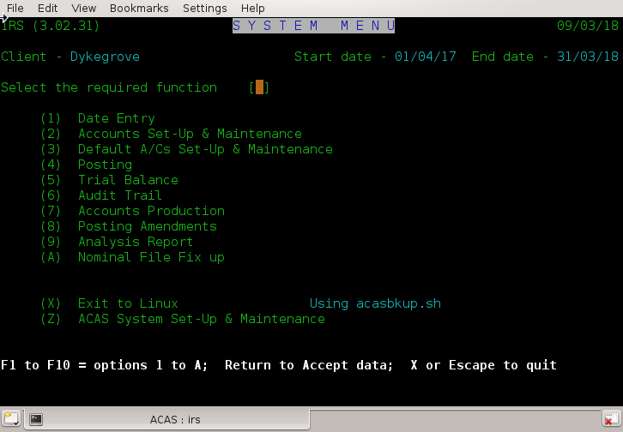
Fig 4.1 System Menu

To run the option you require, simply enter the number or use the function key, e.g., option 5 use F5, option 10 use F10 etc. These options or functions are now described. Option X causes a return to the operating system, and runs the shell script / batch command shown, in this case it is acasbkup.sh (stored in the same directory/folder as the programs and the data by the install procedure) which will make a backup of your data. It is up to you to ensure that the drive you are backing up to is set-up and loaded for writing to. There is no recovery if this not in place, however the user may run the script manually at any time. If the system can not find this script or batch file, a message will be displayed in place of the usual 'using script name' message displayed to the right of the menu (x) option, see fig 4.1.

If this is the first time that IRS has been run, option Z - System Set-up & Maintenance - will be run automatically otherwise Start of Day will run allowing you to change the active date.

The parameter file is used for all sub systems within the ACAS system and is in a chapter all of its own in the manual – Building the ACAS System chapter 18.

These are the important parameters which are required by IRS that may be changed (but again see the manual Building the ACAS System for fuller details) and they are as follows:-
In the User Data screen 1

- Date format, options are UK, USA and International
- The businesses financial year start and end dates.
- The 3 VAT rates - entered as two integer and two decimal places e.g. "20.00" for 20%
If you are based in a country that does not use VAT but Sales tax or similar that can consist of more than one type of tax such as local and federal, add the rates together and enter it as the first tax rate, so local 1% and federal of 5.5%, enter 06.50 then always select this for all taxable items and leave the other two rates as zero.

Note that these parameters are used throughout the ACAS system.

In IRS Data screen 9 - Specific to IRS

- The IRS client name which can be up to twenty four alphabetic characters.
Enter this even if it is the same as the business name.
- The P/L Appropriation or Capital account

Use tab or cursor down to skip to the next field, or cursor up to the previous. Use enter when finished. Using Escape will quit back to the main menu. These functions can be used throughout the program in addition, the function keys F1 through F12 where indicated on the bottom of the screen, can be used to select a menu option in addition to the displayed number, i.e., for option 3 you can use number 3 or the F3 key at the top of your keyboard. Use of the keys: delete, back space, home and end will depend on the way your system is set up.

Note that dates are entered in the same format as defined by the date format mode 1, 2 or 3. Where . , (period or comma) and / can be entered in any combination.

If, during the input of the system parameters, there are already characters between the square brackets, pressing return only, will accept the displayed data in its entirety.

When entering the VAT rate, enter all four digits i.e., not say just '20' for 20.00%. The result, will not be what you expect. Some versions of IRS offers 3 – 5 different Vat rates but the last 2 are for local taxes which are not active in the open source version.

The input for the IRS client name would normally be the same as used in the first time set up screen for the Company Name but could be different and it is this name that is used in reporting.

Chart of Accounts Set-up & Maintenance

Chart of Accounts Set-up and Maintenance - IRS010

Account Overview

Before you can start entering transactions you must set-up a 'Chart of Accounts' and the Default Accounts.

Examples of CoA (Chart of Accounts) for your guidance are provided and set out in chapter 22, page 84. If you decide to use one of the supplied sample charts this may be selected from the Chart of Accounts menu and will not need to be manually entered.

If you wish to use an existing CoA perhaps from another client or from a sample set (see above) then just copy the irsacnts.dat file to the new directory, setup for this client and if not previously done, set up the irs parameter file via main menu option 1. This should be automatically selected.

Now when entering CoA set-up for the first time you will be offered an option to clear down the accounts, see fig 5.1 and you should respond to this by Y having made sure that you ARE in the directory for the new client. The system will then clear all totals for each of the accounts, ready for you to enter any amendments to the CoA and start adding posting, see chapter 7 Posting, page 44.

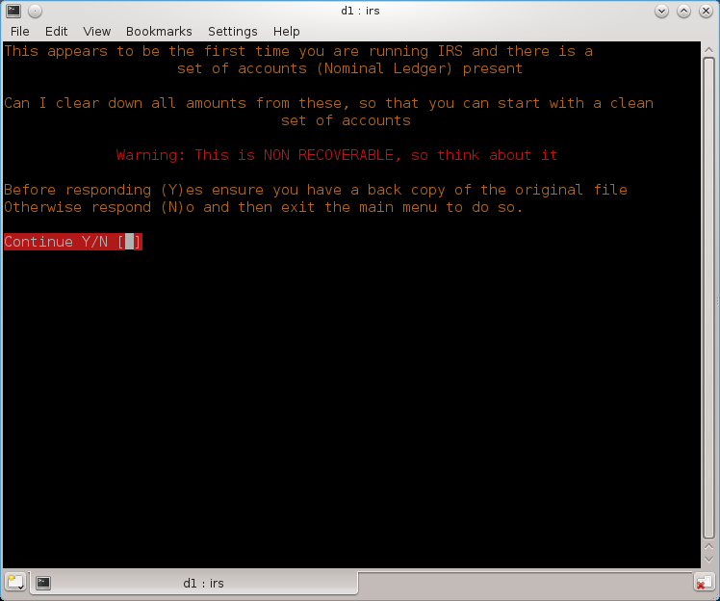
Fig 5.1 Account clear down on first entry

The remainder of this chapter explains the Chart of Accounts for the better understanding of those who select a sample chart and in particular for those who intend to set-up a new chart.

On the ledger for a main account the sub-nominal balances, if any, are shown. Account numbers are five digits for both the main account and the sub-nominal account. IRS can support up to 99,999 accounts. For large Companies that require larger such as 10 digit main and sub nominal accounts contact us for a more suitable product. If however you have the source code you can amend it to allow for larger accounts or for that matter larger money values above 9 Millions (10M -1) for entry and 99 Millions (100M - 1) for totals (display and printing). The following shows one way of doing account coding that makes it easy to remember the main account number from any sub nominal number, there is no doubt there are many others.

For normal operations, main accounts are numbered 101 to 199 and are used to group and sub-total sub-accounts of a particular type. For example a main account may be set-up for 'Light and Heat' as say 115 with sub-accounts 215 as 'Electricity' and 315 as 'Gas'. On a 'Detailed Trial Balance' you would see individual totals for 'Electricity' and for 'Gas' whereas on a 'Summary Trial Balance' it would add these items together and show only one total as 'Light and Heat'.

Each main account can have up to 998 sub-accounts which will automatically be set-up in order. This will allow you for example, to run the same number of customers you give credit to and invoice or suppliers you get credit from. If you have more, just allocate more main accounts for the purpose.

The first sub-account to 101 will be 201, the next 301 etc., up to 99901.

To set-up a chart select (2) from the main menu for 'Accounts Set-up and Maintenance' and then (1) from the sub-menu .

When you enter this process for the first time, certain accounts must be set-up as follows although the numbers are not cast in stone (see the examples in chapter 22 page 84, for more details) :-

Main Sub
a/c a/c

177 VAT. Control account
277 VAT. Input Tax
377 VAT. Output Tax
199 Suspense account
299 Journal Control account
399 Opening Trial Balance account

To continue, enter the number of the first main account you want to set-up, e.g.'101', give it a description, e.g.'Sales'.

The accounts structure is such, that the nature of an account (e.g. revenue or capital, income or expenditure) is defined by a single character rather than by the account number. You are now asked to stipulate the account type, which is a letter from A to Z. The significance of these letters will only become fully apparent to those users who intend to produce final accounts or those that pass their data files on to their accountants who also run IRS.

The first decision to be made is whether the account will affect profit, i.e. whether it is a 'profit and loss' or 'income and expenditure' account in which event use a letter from A to N or, if the account is a balance sheet account use a letter from O to Z.

Within the groups A - N and O - Z, IRS recognises eight different account types and allocates various groups of letters to them. The sample chart/s at chapter 22 page 84, shows example/s of which account type to use and a greater understanding can also be obtained by reference to the chapter on double-entry book keeping at chapters 3.3 and 24. The accounts structure is such that the nature of an account (e.g. revenue or capital, income or expenditure) is defined by a single character rather than by the account number. IRS recognises eight different account types and allocates various groups of letters to them. The account types have groups of letters associated with them in order to increase flexibility when defining the layout of the final accounts (see chapter 6.6 page 42). The account types and their associated letters are shown below:-

Income Accounts A to D
Direct Cost Accounts E to H
Sundry Income Accounts I to J
Indirect Cost Accounts K to N
Fixed Assets O to Q
Current Assets R to T
Current Liabilities U to V
Capital Accounts W to Z

As a review and that can be seen above, letters A to N relate to the Profit and Loss Account, and O to Z to the Balance Sheet.

For 'Sales Invoicing' you would enter 'A' (or any letter from A to D). The accounts structure supports sub-nominal accounts such that accounts may be divided into main (or owning) accounts and sub-accounts. On the final accounts, only main accounts are reported and they show the cumulative balance on themselves and their sub-nominals.

If at this juncture, you want to add sub-accounts (which can be done now or later) then enter 'Y' to 'Add Subs' and then a description for the first Sub-account e.g. 'Sales – A. N. Company Ltd'.

Continue entering sub-accounts until complete and then press <Return> where the sub-account is zero to allow you to enter the next main account number. Using this method you can continue adding all your customers that you give credit to and invoice. Similarly, do the same for your suppliers that invoice you, if you do not wish to use the full ACAS PL or SL systems although using them will automate a lot of the postings.

When you have entered your chart, this can be displayed by selecting (3) from the 'Chart of Accounts Set-up and Maintenance' menu, or printed by selecting (4) from the same menu.

If you discover any errors in the chart, these can be amended by selecting (2) from the Sub Menu, which selection is also used to add subs to a Main Account which has already been set-up.

Upon entry to this function, the user will be presented with a group menu containing five functions, each of which is now fully described next, in chapter 5.2 also see figure. 5.2.

Set-up Chart of Accounts
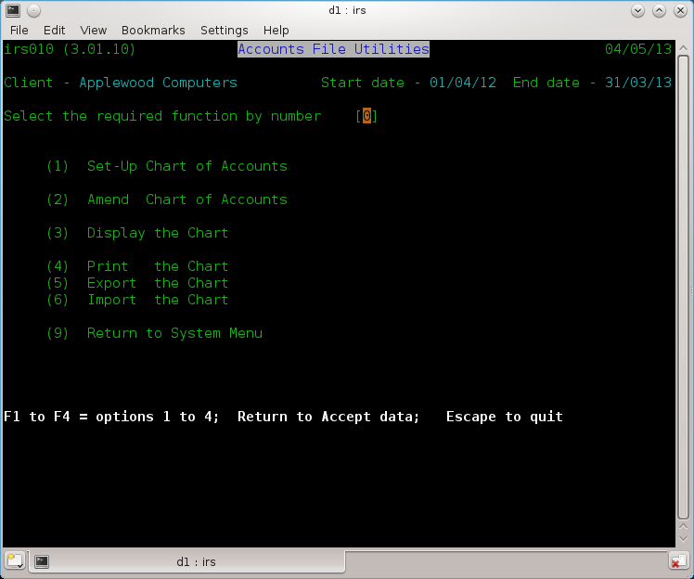

Fig 5.2 Account file Utilities

This function allows a new Chart of Accounts to be created, and also allows new accounts to be added to an existing Chart. Note that this function will only add sub-nominals to the chart at the same time as the owning account is created. To add sub-nominals at any other time, use function 2. Amend.

Upon entry, the you are asked if you wish to add to an existing chart? The answer to the question is of crucial importance. Answering "N" (for no) erases the current chart. This is so important that additional warnings are also displayed in Red to help force you to think about this question before answering.

Thereafter, the next screen is displayed for the input of information. The first item keyed in is the main account number (owning) which is checked, and rejected if already in use on this chart, see fig. 5.3.

The next item to enter is headed "Sub-Nominal" to which the response is either "Y" for yes or "N" for no. Answering "Y" implies that the account being set-up is an owning account and the user will be given an opportunity to enter sub-nominal accounts to the owning account.

Answering "N" or just hitting return implies that the account is a main account without sub-nominals.

Regardless of the answer to the above question the user will next be asked for the name of the account. Twenty-four characters are allowed.

Following this, the last item to be entered is the Account Type. Enter a letter in the range A to Z, to specify where you wish it to appear in the final accounts.

At this point, the response to the sub-nominal question determines the information that is entered on the next line.

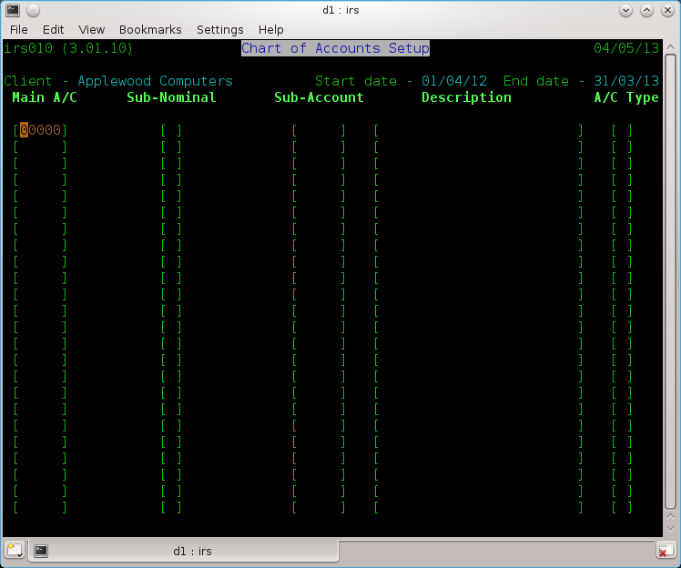
Fig. 5.3 Chart of Account Setup

If the response was no, the user will be prompted for the main account number required, and the input process for a main account is repeated. Note that typing return to this question (i.e. entering no value whatsoever) causes the system to exit from the function and return to the group menu.

If the response was yes to the sub-nominal question, the input on the line below will be for a sub-nominal account number followed by its description only. Note that a sub-nominal account automatically takes the same account type as its owning account. This input cycle of sub-account followed by its description continues until a return only is entered for the sub-account number, which terminates the entry of sub-nominal accounts and allows a new owning account to be entered.

The simple rule to remember is that a blank sub-account number i.e. return allows another main account to be input and a blank main account number allows the user to exit to the group menu.

After each group of entries, the screen clears and entry starts again from the top.

Amend the Chart of Accounts

This function is provided to permit the following:-

i. Amendment of a main or sub-nominal account.

ii. Addition of a sub-nominal account when its main account already exists.

iii. Deletion of an owning account and all its sub-nominal accounts (if any).

The screen displayed is identical to the screen shown in figure 5.3. In actual usage there are functional differences, the major difference being that for all data to be entered the main account number must be entered first and must exist. The function is now discussed in terms of its three sub-functions.

Amendments

By definition the account to be amended must be present within the chart. On entering the main account number the description will be displayed in the appropriate area. The cursor will be positioned in the Sub-Nominal field. If the main account is to be updated enter "N" (for no). If the sub-nominal account is to be updated enter "Y" (for yes). This will cause a request for the sub-nominal account number to be entered. At this point the name of the account to be amended will be displayed. The name may then be updated as required, or accepted by hitting the return key, following which the account type may be similarly changed or accepted. Entering a “D” will delete this account.

The cursor will next be positioned in the main account field, and a main account may be entered for update. Just hitting the return key will exit to the group menu.

Addition

Initially proceed as above for amending an existing sub-nominal but enter the account number for the new sub-nominal account as a sub-account. The description may then be entered and the new account will be stored in the chart.

Deletion

The user may only delete main accounts. Doing so will cause the deletion of any associated sub-nominals accounts. To delete a main account enter its number as previously described and then "D" to the sub-nominals question.
You must not delete any (main or sub-nominals) accounts that have any postings so check it beforehand.

Print the Chart of Accounts

On selection, this function first prompts the user to ensure that the printer is ready and then prints the entire chart of accounts in the same format as the display.

Display the Chart of Accounts

This function displays the chart on the screen. The display is in ascending main account sequence with sub-nominals shown immediately after their owning account.

On each screen fifteen or more (depending on screen size) accounts are displayed, after which the user may enter "X" to exit or "N" to display the next screen. After displaying the last screen the user enters any key to return to the group menu. The "X" facility is provided to allow the user to terminate the display and return to the group menu at any time.

Export the Chart

This function allows you to save a copy of the current chart to a text or comma delimited file. The text file is the default option and you can edit it using any text editor, see fig 5.4.

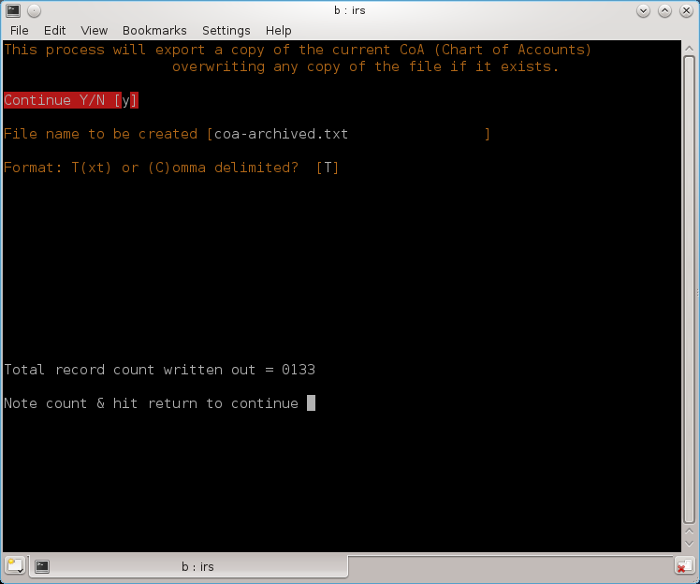
Fig 5.4 Exporting the Chart

On entry, you will be asked to confirm selection, file name and file type default is T (for Text) that can be imported using option 6 (see the next function) as well as a comma delimited file which can be imported into a spreadsheet or word processor, e.g., the open source LibreOffice package, which is a free `product as against the Microsoft Office which is not.

This file, can only be edited using a standard text editor and not a word processor tool as the format will not then be in text form also see chapter 22 page 84 for an example of the resulting file content.

Import the Chart

You can import a text (only) copy of a Chart that was previously exported (see 5.3.6) or created using a text editor.

On entry you will be asked to confirm the process as this will overwrite any accounts file present and this is not recoverable so make sure you have backed it up. Next you will need to enter the name of the file to be imported that is in the current directory or a path/file name not exceeding 32 characters, see Figure 5.5). Any existing chart will be deleted and the new one created.

All totals etc., are cleared down to zeros ready for you to use or amend as needed. See chapter 22 page 84 for a list of an example of a such a file

Fig 5.5 Import the Chart

Return to System Menu

This function returns the user to the main system menu.

Note The Chart of Accounts must be created before using any program other than System parameter set up, which must be then followed by the Default Accounts, see chapter 6 next.

Default Accounts Set-up & Maintenance

Default Accounts - IRS020

Default accounts are a central feature of IRS and should be clearly understood. IRS will not permit single entry posting, entering both the debit and credit for each posting is time consuming and prone to error. VAT accounting requires that, for each posting, the user knows (a) whether the posting is VAT related and (b) if the VAT is input or output. It is also necessary to apply to each posting a simple code for reporting purposes. The final consideration is the desirability of having a single input format for all postings which will automatically build up a VAT Day Book providing both VAT or Tax and statistical totals. The solution to all of the above is Default Posting. The user, by setting up the defaults, defines the contra-accounts which are to be used. The system supports 32 contra-accounts at any given time. To set-up the defaults, the user must supply three pieces of information for each default account. These are:-

An Account Number

This can only be a number of an account which already exists in the chart of accounts. In most cases the following accounts should be used as defaults:-

Bank Account
Cash Account
Journal Control

The Transaction Code

This two letter code will be printed on all detailed transaction reports and using the accounts mentioned above could be:-

BE = Bank expenditure VAT Input
BI = Bank income VAT Output
BK = Bank income or ex non VAT
CE = Cash expenditure VAT Input
etc,

The VAT type

As (I) input, (O) output or (N) none.

Defaults 30, 31 & 32 are dedicated to:-

31 VAT Inputs (Purchases)
32 VAT Outputs (Sales)

as well as:

30 Opening Trial Balance
Which although is not a vat account must be coded the same.

All of which must be VAT type coded "N" for None.

During postings it is vital that you use the correct default, taking into account the settings for VAT and on what side i.e., Input or Output.

Defaults 1 to 29 inclusive are available for any account the user requires. All accounts used for default accounts must already exist in the chart of accounts. While the user is able to utilise the accounts and defaults at his/her own discretion the following advice may prove useful.

During posting it is only necessary to specify the number of the default account and whether the batch is a debit (To) or credit (From) batch for IRS to meet the criteria outlined above. The user then, for any transaction, only has to input the date, contra-account, narrative, amount and, if necessary, the VAT code.

It should be noted that a single account may be used in several defaults e.g. the Cash and Bank Accounts would normally be found in at least three default accounts with one each of input, output and none as the associated VAT types. Likewise the associated default codes could be BI, BE and BK for Bank Income, Bank Expenditure and Bankings respectively.

By using this system, restrictions on the number of Bank or Cash accounts within the 29 default parameters are removed, journals are also created by setting up and defining as a default a Journal Control Account. The two character default codes can later be used at the reporting stage as a retrieval parameter.

On entry to this function the user will be shown and prompted to select one of the six options as discussed below.

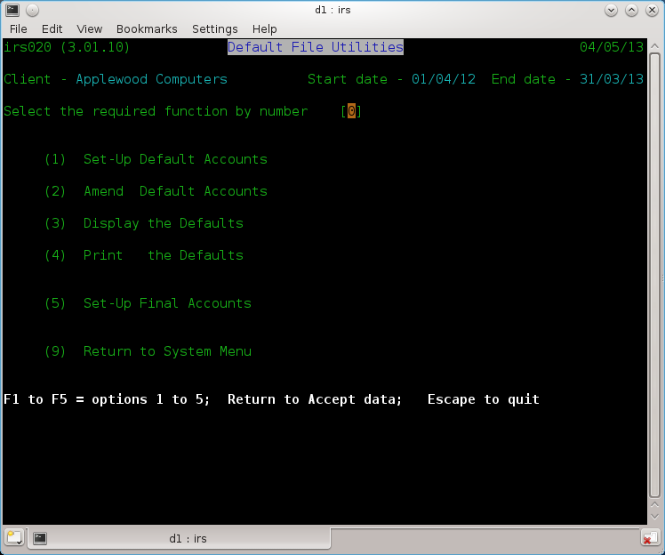
Fig. 6.1 Default Accounts Setup

Set-up Default Accounts

VAT Accounts and Defaults

It is suggested that a main account say 177 is designated as a VAT Control Account and sub-accounts 277 VAT Inputs and 377 VAT Outputs are created, sub-accounts 477 for payments and refunds and sub-account 577 for Direct VAT Postings, this latter account being useful for dealing with correcting invoices rendered or received for VAT only and other similar infrequent transactions. The same system can also be used for users who's country does not use the VAT system but one that does use Sales Tax and therefore will allow you to record tax both paid out and received. The VAT method is used in many other countries than the United Kingdom such as the EU, Australia - although in some, it might be called GST.

Suspense Account

This should always be a main account say 199 and may have numerous sub-accounts i.e. cash sales control 299, journal control 399, petty cash 499 and 599 say for directors A and B, general suspense 699, petty cash for staff & others 799 and Opening Trial Balance (or OTB) 99999, all of which should never produce a balance but in the event of an erroneous balance being generated, it would appear in Suspense Account..

Upon entry the question "Add to existing defaults?" is asked. Entering "N" (for no) deletes the existing file whilst "Y" (for yes) permits a speedy update to existing defaults.

Each default is numbered, and for each one the user must supply the number of an account which exists within the chart of accounts, a two character code, and the VAT type which must be either "I" for input tax, "O" for output tax or "N" for no VAT. For users that need to use Sales Tax and/or local sales tax, instead of VAT or GST use the same methodology even if you cannot reclaim tax on purchases. In this way you can easily see the amount spend on such and received.

Default entry is terminated with an account code of zero, which can be achieved simply by hitting return only to the input account code prompt..

Once done the system will prompt for defaults 30, 31 and 32 which must be the opening trial balance, Input and Output VAT accounts respectively. This function does not terminate to the group menu but automatically loads the amendment routine.

IRS as of v3.02, also allows for default 33, which is a temporary account for this run only during Postings, as it does not retain the information.

This method is also used with the General Ledger system.

Amend Default Accounts

This function allows one or more defaults to be amended. The default is amended in the same way as it was added in chapter 6.2. The difference is that each default to be amended has to be specified by number. The default number is entered at the bottom of the screen in the space provided. A screen is shown in figure 6.2.

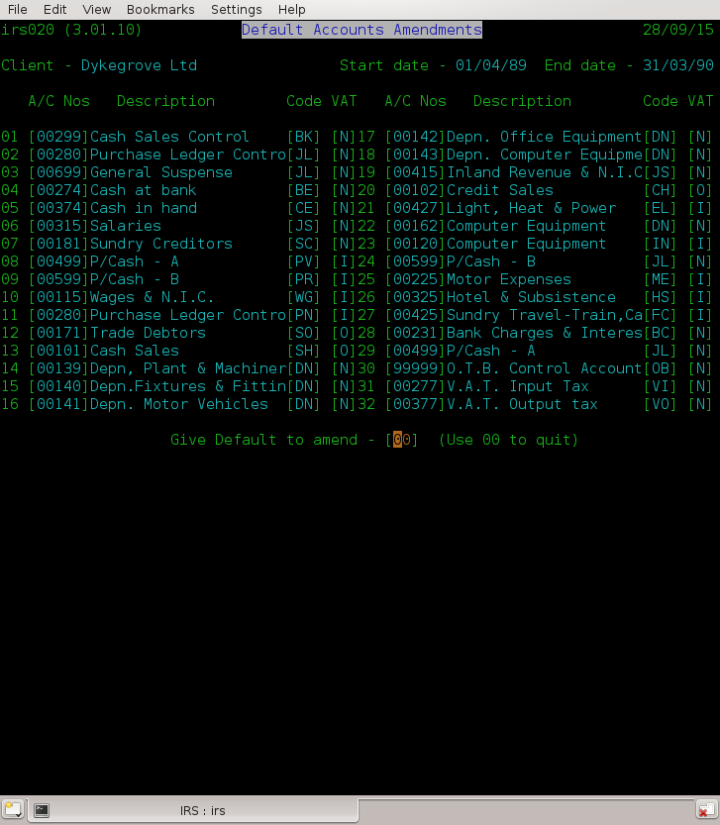
Fig 6.2 Amend Defaults

Display Default Accounts

This function produces a simple display of the defaults as held on the Defaults file. This function is also implemented in the posting procedure to allow the defaults to be displayed at the time they are actually used. See figure 6.3.

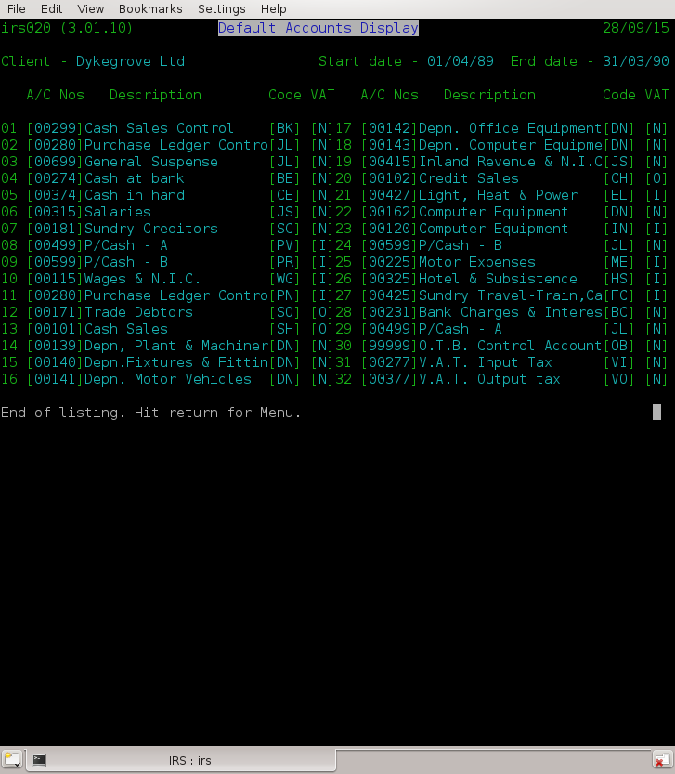
Fig 6.3 Defaults Display

Print the Defaults

This function is provided to allow a print-out of the defaults to be produced. At the same time, the Final Accounts details along with the P & L (Profit and Loss) appropriation account is also printed on a separate page.

Set-up Final Accounts

A single function is implemented for setting-up the final accounts. Screen example is shown in figure 6.4. At the present time, please ignore the column marked sign as this is provided for possible future use although you can enter values '+' or '-' now. These headings will be automatically used in place of the default ones. If in doubt, leave these all blank. They would not be normally needed or used, however the last field on the screen P & L Appropriation Account is used.

The Profit and Loss Account, enter it or the Capital account that will be used to transfer profit or loss for next years accounts using Final account production and end of year processing, (see chapter 10 Final Accounts, page 50). This account will be checked that it exists in the CoA.

Use the various arrow or tab keys to travel around the screen (figure 6.5) and only enter heading narratives against those letters which are actively used in the chart of accounts. At this point enter or return to complete input.

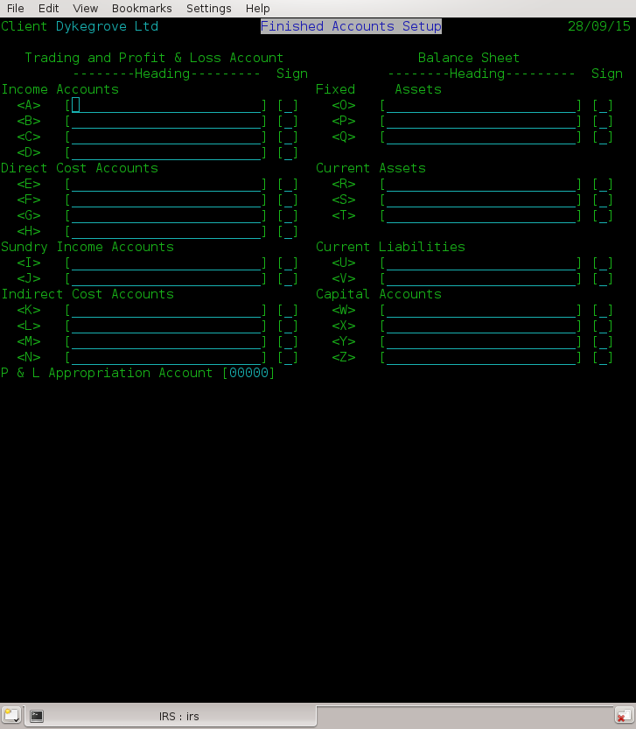
Fig 6.4 Set up Final Accounts

ESCape Depending on program will quit the current activity or program
Return Sends all data on screen to program
Home Moves cursor to start of first field
^ (arrow up) Moves cursor to start of previous field
Back Tab Moves cursor to start of previous field
v (arrow down) Moves cursor to start of next field
Tab Moves cursor to start of next field
← Moves cursor left one position
→ Moves cursor right one position
. (stop char) Inserts leading zeros into field
(Note this one may differ if using the GnuCOBOL compiler version)

Fig 6.5 Cursor Movement keys

Posting – IRS030

Although IRS is not a true batch system, transactions are entered in what are effectively batches. Each batch relates to a particular default account. Upon entry to this part of IRS and before actually making the postings, it is necessary to identify to the system the type of postings that will be made.

This is done by answering the following four questions:-

Enter run option

This has four possible responses as follows:-

a) 99 Displays the existing defaults The same way as in chapter 6.4.
b) 88 Adds the batch to be entered to the current file of postings.
c) 77 Clears the existing file of postings and starts the file anew with the
postings to be entered.
d) 66 Add PL or SL Postings from file.
e) <Return> Exits to the Main Menu.

Selecting option “77” should only be done after final accounts have been produced and EoY (End of Year) processing completed at best, as the EoY will do this if requested. Of course it is recommended that a back up of your data must be completed prior to running final account (see chapter 10, page 50) or selecting “77”. Both functions are otherwise not recoverable.
Select this option will clear the file down immediately without any further questions, etc., so do not use for normal processing unless really needed.

Remember, exiting the IRS system will run a back up script.

Running EoY processing, clears down the posting file to create B/F (Brought forward) postings for the new year. This is not recoverable so ensure you have a current back up prior to doing so.

Selecting option “66” will post transactions from Sales and/or Purchase ledgers to the posting file so that they are merged with transaction entered through IRS. There are some error messages that can appear that will show that system settings within P/L or S/L are incorrect but this should not normally happen. At the end of processing, a display will provide you will a record count along with a request to clear down the temporary file. You will normally enter “Y”, as otherwise they will be reposted the next time you run this function.

Having selected 88, you will be asked four questions and until you are familiar with the program you will need to think carefully about the answers.

A discussion of posting methods is also included at Chapter 3.3, in that this will vary from business to business and you will need to select the methods which will be most appropriate for you. An explanation of the four questions is now given:

Enter Default Number

or

Posting from which account?

This allows selection of the default to be used. Pick the right one with VAT in mind and is the default account to which the total of each posting will default to.

E.g., If you were posting cheque payments you would enter the account number which you have set up to be the bank account.

Whenever you are asked for an account number you can use function key F1 to list the defaults currently set up and after pressing return, it will continue back to requesting an account number.

Whenever you are asked for an account number you can use function key 'F4 and enter any part of the account name. If the entry is ambiguous you will be given a list of the relevant accounts from which you may choose.
Note this is not available for ACAS v3.01 & for v3.02 as of 19/08/2023 and sl030 v3.02.030.

It's description will be displayed and you have to confirm that it is the correct account..

Please note that here and in 7.4 the question can differ depending on software version used.

If you need a temporary default account just for this run, enter 33 and you will be asked for the account number as well as the Code to be used for transactions and the VAT code (I, O, N).

Correct Account (Y/N)

The account description and VAT type associated with the default are displayed, and this question is used to allow confirmation that the correct default has been selected.

Enter Run Characteristics (DR) or (CR)

or

Debit or Credit?

"DR" if the accounts to be entered are debited and the default account credited.
"CR" if the accounts to be entered are credited and the default account debited.

Payments made to others by cheque or cash would be debit 'DR', monies received would be credit 'CR'.

If the series of transactions which you are about to enter are mainly payments then enter <DR>, if during the run you want to enter an occasional receipt this can still be done by preceding the amount with a minus sign '-'. Having entered the answer, the main posting screen will appear. A split screen is used with all entries being kept to the bottom four lines of the screen, with one exception which is discussed later. The entries to be made are as follows:-

(1) Date - Should be entered as dd/mm/yy. i.e., day as 01 to 31, Month as 01 to 12 and the year for the UK, reversing Month and Day for the US format, and as Year, Month then Day for International. If spaces are entered the batch will end. If function key F3 is entered the batch will end before a request for a new default account. See 7.2.

(2) Account - The account number of the main or sub-nominal account of the posting. If zero is entered the batch will end.

(3) Narrative - Thirty-two characters are provided for a legend. On the screen only, this is contracted to sixteen characters.

(4) Amount - This is the net or gross amount of the transaction according to the VAT type. A zero amount will abort the posting returning to the date request.

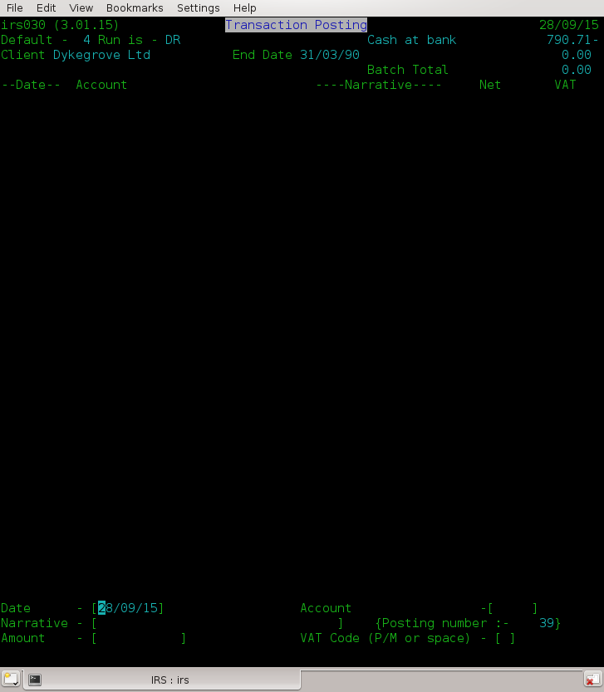
Fig 7.1 Transaction Posting

Mistakes during posting

If you make a mistake whilst posting, before you have accepted the amount, enter a nil amount and the transaction will not be entered into the system.

If you have accepted the amount before you notice the error then make a note of the posting number and correct the mistake through Posting Amendments. (See chapter 11, page 52.)

(5) VAT Code - This is only requested if an input or output tax default account has been used, and should be entered as:-

If "P" is inserted, the system will calculate the amount of VAT to be added to the transaction amount entered and will display the VAT calculated, you may either accept the amount by hitting Return or delete the integer of the amount and enter an amended figure. You may also use the arrow keys to move then modify an incorrect character. This also works with 'M' as discussed below. This function is useful for checking the VAT shown on input documents.

If "M" is used the system will calculate the amount of VAT to be deducted from the transaction amount entered, amend the transaction and insert the VAT. You may either accept or alter the amount as for "P". If you alter the VAT amount the Net will be adjusted automatically, with Net and VAT redisplayed.

If Space is used then the VAT amount can be entered manually or return can be used for Non VAT (Zero Rated) items.

Entering Zero Rated items through the medium of either Input or Output Default Accounts, ensures that they appear in the statistics columns of the VAT day book.

Entry of transactions outside the scope of VAT should be via ("N"/Non Vat Defaults), these entries will not then appear on the VAT day book.

A minimum of fourteen postings (the maximum will depend on your screen size) can be entered on each screen. When the screen is full, the last transaction will be moved to the top of the next screen and the rest of the list cleared.

To exit once a batch has been entered type return only to the Account prompt.

As items are input the current balance on both the default account and the VAT account is displayed along with a running batch total. A transaction number is allocated to each posting that is entered.

NB: The transaction number will be required when utilising the Posting Amendments facility.
A minus sign following the amount reverses the default posting convention for that transaction only. e.g., When in a debit run a minus sign will credit the posting.

Important:
Under the GnuCOBOL compiler, when entering or amending numbers and amounts you will have to key in the full number including the full stop and the pence, i.e., 29.45. You can, use the left and right arrow keys to position to the digit you wish to change. Using Micro Focus Cobol this works as expected. So for the above value enter 29.45 followed by return or if negative enter “-” first or last. Some versions of GnuCobol require you to enter the full number as in the above example as 000000029.45 and not 29.45. The full stop and the pence/cents must be keyed even for 0.00. You can also use the right arrow key to position to the exact point you need to enter data if it is showing zeroes but the period must be entered as well.

Changing the Default Account whilst posting transactions

If you are entering purchase invoices, you will possibly be defaulting through the suppliers account. The next invoice to be entered may be for a different supplier.

To prevent your having to come out of the posting screen to change the account from which you are posting, there is a facility to press function key F3 when asked for the date in order to change the default. You will see the message "F3 for new default" to the right of the date entry box to remind you. Please note that there is a short delay (.5 to 2 seconds) when pressing a function key or the escape key for the program to respond, again due to the current version of GnuCobol (v3) running under Linux. Hopefully this problem will be fixed in a later release. It is recommended that the user has a print out of the defaults to hand.

Trial Balance - IRS040

Selected from the Main Menu as Function 5 or F5.

You can select a detailed or summary trial balance that can either be displayed or printed. In either case accounts with zero balances may be included or omitted. The Trial Balance order is ascending by Main Account Number with sub-nominals immediately after their owning accounts (if detailed trial balance has been selected). A summary trial balance will accumulate all postings to 'sub' accounts into the respective 'main' account and will display 'main' account totals only. When displaying the Trial Balance, at the end of each page the user is asked whether the next page is required or not so that the display may be aborted if no further information is required.

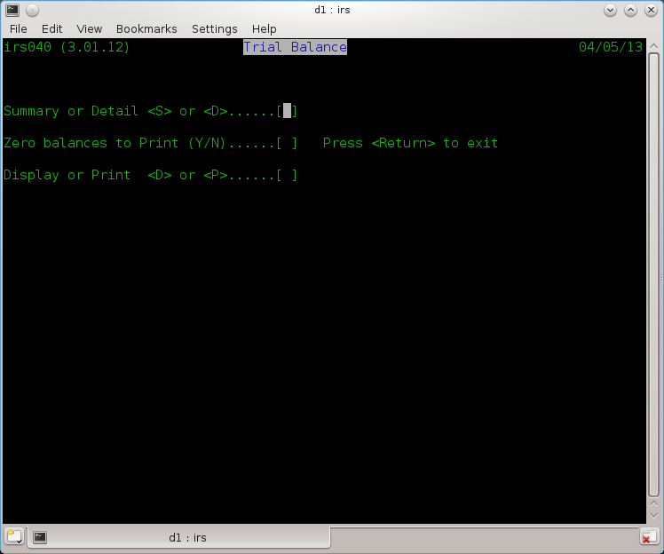
Fig 8.1 Trial Balance Reports

The Audit Trail - IRS050

Selected from the main menu as function 6 or F6.

There are three primary reports or displays available. Fig 9.1 These are:-
A - Audit Report
L - Ledgers
D - Day Book

All can be in any one of three sequences :-
1. Code order
2. Date order
3. Transaction order

(1) Audit Trail
The Audit Report is a listing of postings entered into the system. It can be used to list all postings or used selectively to list only those postings having a given code. e.g. "BE" (Bank Expenditure Input VAT), "JE" (Journal debits Input VAT) etc.

(2) Ledgers
The Ledger Report produces either the ledger page for an individual account or a report for all accounts. Sub-nominal balances are also shown. Entering zero or just return as the account number will produce all accounts which is particularly useful at the year end in order to obtain full hard copy print out.

(3) Day Book
The Day Book produces a VAT listing of all transactions entered against VAT "I", "O" or “N” default accounts. When this selection is made, start and end dates for the report must also be entered, as this will produce quarterly reports which provide the totals for insertion in the VAT returns, both for tax and statistics.
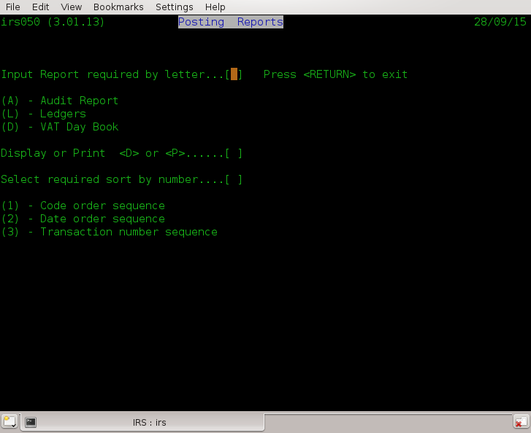
Fig 9.1 Audit Trail menu

The Final Accounts - IRS060

Selected from the Main Menu as Function 7 or F7.

This function prints the Profit & Loss Report, Balance Sheet and optionally, processes the end of year cycle.

If the Final Accounts has been created in irs020, then any entries for a given account type will replace the CoA (Chart of Accounts) entry of the same type. For normal usage this function is not needed but allows a replacement title for a main account in the CoA for reports.

Gross and Net Profit percentages are expressed in the same way, i.e. as a percentage of Sales.

To initiate the production of the accounts, select the comparative field which contains last year's figures. If there is no requirement for comparative figures (or none exist as this is the first year using IRS for this business or client), select 0 (zero). The comparatives are from one to four, i.e., the last four years prior to current.

After printing the accounts and balances the system will ask:-

"Do you require end of year processing?"

Before saying Yes to this, you should ensure that your have made a backup of your data files in case of any problems, as this changes accounts, and this is not recoverable using the Fix-up function (chapter 12, page 53). If in doubt just exit the system using option X then restart irs and reselect this option (For v3.02 and later) as a back up will have been made for you using the defined script,-see menu option X text to the right, i.e., using acasbkup.sh. This is supplied with the system and you can change it if it is not doing what you require see chapter 18.1 page 72.

The user should answer "Y" for yes or "N" for no. If the answer is no, the main menu will be shown, otherwise the system will ask for the comparative area (1-4) in which to store the figures and a profit and loss appropriation account in which to carry forward the profit or loss. The comparatives must be between one and four inclusive and the profit and Loss Account must exist within the chart of accounts. This is discussed twice for a good reason, for why see below. The P & L account as defined in chapter 10 the Final Accounts screen, page 50.

End of year processing copies all the balances to the comparative selected. The current balance for all revenue accounts are set to zero, but those for capital accounts are unchanged except that the account nominated for the Profit and Loss Appropriation which has it's balance updated by the Profit or Loss. The system is now ready to accept the new year or period inputs.

A back up at this point is recommended eg, exit the system and then rerun IRS to allow the automatic back up to occur assuming you have the backup script in place. You may want to copy the back up just created to another file renaming it to something you will remember and understand such as backup-eoy-2015-16-(today's date & time).tar.gz.

For version v3.02 this will be done for you using the respective two scripts detailed in chapters 18.2 and 18.3 respectively and that will produce back ups ending with the names :

-Pre-EOY
-Post-EOY

Amend Postings - IRS070

Use this procedure to correct any errors you have made when posting a transaction.

Selected from the Main Menu as Function 8 or F8. This function is provided to allow previously entered postings to be amended or deleted. Postings are referenced by their IRS transaction numbers. It is useful, therefore, to produce an audit report before attempting to use this facility.

On entering the transaction number the posting is retrieved while a message

"Reversing posting - Please wait" is displayed.

The posting has now been effectively deleted. It is then displayed along with the message "Correct the transaction". At this point any or all fields may be amended. To leave a field as it is, simply hit return only. Please note that negative amounts may not be entered. After entering the VAT, the transaction is restored to the file suitably updated.

To leave this function enter a transaction number of zero.
To delete the displayed transaction, enter a code of "**" (star star).

On exit from this function the user will be given the opportunity to renumber the transactions. If the transactions are renumbered, they are sorted into date order at the same time. This will of course mean that any previous numbering will no longer be correct. If a transaction number is entered which does not exist an error message is given and the prompt for transaction number is repeated.

Using the renumbering function will remove the ability of an audit trail. For a company, the correct and recommended way of correcting a posting to say the wrong account, is to enter a posting to contra it off and add it to the correct account. However the facility might be handy for accountants and their book keepers in certain conditions.

The Amend Postings facility is more commonly used to correct entries made when posting rather than making additional correcting entries. Before exiting from the posting mode, note the current transaction number displayed and calculate the transaction number you wish to amend or delete.

Errors observed whilst checking printouts are easily corrected in this mode as all printout entries record the transaction numbers.

Nominal File Fix up - IRS080

Selected from the main menu as function A or F10.

Sometimes, due either to misuse of posting VAT, during Posting Amendments or hardware failure the Trail Balance goes out of balance compared to the individual balances on the ledgers. This program, will repair the General (Nominal) ledger accounts file by clearing current balances and reposting all entries from the Post File.

This process will sometimes become needed if using Posting Amendments where the VAT element is changed from None to I or O or O to I etc. It is suggested that any time such an amendment is made, this program is run before the end of the day just as a safeguard.

NOTE – It is recommended to make a back up copy of ALL data files prior to running, in case of hardware or power failure or even a bug in the software, by exiting the system which will run the backup script then reloading it.

Analysis Report - IRS090

Selected from the main menu as function 9 or F9.

This function will produce a monthly analysis by account number of all postings. This can be used for budgeting purposes.

Before starting, the system will request the month your tax year starts, i.e. new financial year starts April (which is common for the UK), then enter 04 (fourth month).

As this process will read every posting it can take some time depending on the number of transactions and the speed of your computer.

ACAS System wide File and RDBMS Table Usage Chart

The following chapters are to assist along with the ACAS system specific manuals, the full usage of the ACAS systems.

File # | File name | Table name  [ -rec ] | DAL (MT) | Isam? | GL | IRS | Sales | Purchase | Stock
00 | system | system  sysdeflt  sysfinal  systot | system  dflt  final  sys4 | Rel | rw | rw | rw | rw | rw
01 | glwork | n/a | n/a | ???
02 | archive | n/a | n/a | Seq | rw?
03 | final | n/a | n/a | Seq | rw
05 | ledger | glledger | nominal | IS | rw
06 | posting | glposting | glposting | IS | rw |  | w | w
07 | batch | glbatch | glbatch | IS | rw |  | w? | w?
08 | postings2irs | psirspost | slposting | IS |  |  | w | w | w
09 | tmp-stock | n/a | n/a | Seq |  |  |  |  | rw
10 | staudit | stockaudit | audit | IS |  |  |  |  | rw
11 | stockctl | stock | stock | IS 3i |  |  |  |  | rw
12 | salesled | saledger | sales | IS |  |  | rw
13 | value | valueanal | value | IS
14 | delivery | delivery-record??? | delivery | IS |  |  | rw
15 | analysis | analysis | anal | IS |  |  |  |  | r
16 | invoice | sainvoice  sainv-lines | slinvoice | IS |  |  | rw
17 | delinvno | sadelinv | sldelinvnos | IS |  |  | rw
18 | openitm2 | n/a | n/a | Seq |  |  | rw
19 | openitm3 | saitm3 | otm3 | IS |  |  | rw
20 | oisort | n/a | n/a | Seq
21 | Work.tmp | n/a | n/a | Seq | rw
22 | purchled | puledger | purch | IS |  |  |  | rw | r
23 | delfolio | pudelinv?? | delfolio | IS
26 | pinvoice | puinvoice  puinv-lines | pinvoice | IS |  |  |  | rw
27 | poisort | n/a | n/a | Seq |  |  |  | rw
28 | openitm4 | n/a | n/a | Seq |  |  |  | rw
29 | openitm5 | puitm5 | otm5 | IS |  |  |  | rw
32 | pay | plpay | payments | IS |  |  |  | rw
33 | check | n/a | n/a | Seq |  |  |  | rw
34 | irsacnts | irsnl | irsnominal | IS |  | rw
35 | irsdflt | irsdflt | irsdflt | IS |  | rw
36 | irspost | irsposting | irsposting | IS |  | rw
37 | irsfinal | irsfinal | irsfinal | IS |  | rw
38 | postsort | n/a | n/a | Seq |  | rw
## | Various temp names | n/a | n/a | Seq | rw
ACAS File usage Table

rw = Read/Write IS = Indexed sequential
r = Read only IS 3i = Indexed Sequential but with 3 keys
w = Write only Seq = Sequential
Rel = Relative
n/a = Not Applicable – Cobol file only.

Unless otherwise indicated all files have an extension of “.dat”
## Other files exist during General Ledger running but all with extension “,tmp”
## The other systems use temp file ending .dat and are not deleted others with .wrk are deleted at end.
All temporary files are stored in current directory usually as pointed to by environment variable
ACAS-LEDGERS set up by the install-acas.sh script. The script install-ACAS-preinstalled.sh does not do this as it is previously done by the former script..
All temporary files tend to be small but not greater in size than any primary files.
All RDBMS table names end with ‘-REC’ and are ALL upper-case.
All DAL modules names end in MT but not shown above.
ALL Cobol → table loader programs have same name as DAL but ends in LD..
ALL FH modules take their name using File number (#) e.g., file 32 FH is acas032.
IRS is slightly different these are named acasirsub1, 3, 4 and 5 that replaced the old FH called sub1, 3, 4 & 5.

The invoice tables have secondary tables that are directly linked but not listed above.

Migration to other RDBMS systems will use same names but stored in another sub directory under DAL within common which already has MySQL DALs in MySQL. Copied from the common directory.

The FH (File Handlers) in both common and FH are consistent regardless of RDBMS used.

Reporting problems with ACAS products

Use the bug reporting function on the ACAS sourceforge website for both problems in the software and in any supplied manual. Do not forget to specify the name & version of the program with the problem, also specify the level of the issues such as : -

Priority
Level Title Description

1. Critical Cannot run a previously working ACAS system.
2 Urgent Can run the system but cannot work with some functions.
3 Partial A function is not working as described in manual.
4 Function Needs additional functionality.
5 Cosmetic A minor problem such as in screen display layout or the colours used
or the way data is entered.
6 Undefined Low priority issue not within other levels.

Commercial users should also prefix priority number with a ‘C’.
Level 1 is same day / 4 hours. [with prefix C otherwise 24 hours, where possible].
Level 2 is same day / 12 hours. [with prefix C otherwise 72 hours, where possible].
Level 3 & 4 is 3 days. [with prefix C otherwise, as time permits].
Level 5 & 6 is as time permits. [with prefix C, as time permits].

E & OE Applies.
The above timings is on a best effort basis only as holidays etc can interfere with these.

Commercial users with active maintenance contracts, can also use the direct website as outlined in the supplied support documentation and the email address mention below for problem reporting.

If it is critical or urgent you can also send an email, see address on inside cover but still use the bug reporting system so other users can see that it has been reported.

Remember if it is not reported – It cannot be fixed and do not assume that some one else has reported it. Check the bug lists to see.

If in doubt issue a bug report. if warranted, retain all data files in case they need to be sent in (but only after archiving them with zip, rar or tar with a file name indicating the customer / user).

Subject to the problem you may be asked to send these in for inspection. After the problem has been located and resolved, these files will be deleted.

Error messages used within the ACAS system

This chapter is taken from the ACAS - Building the ACAS System manual and here for your reference.

Here is a list by system and program of all messages that signify an error or warning that can appear. However there are warning messages that can appear during data entry that are not listed.

Cobol and C Error Messages

Applewood Computers software is designed to trap almost all errors which can arise under normal circumstances, but due to language limitations and/or hardware problems, some errors may occur which the programs themselves cannot handle. These errors are Cobol or C errors – see File Access Error numbers. You should look at the Cobol compiler documentation for more information as these can change between versions of both the Cobol compiler as well as the GCC C compiler. Also see RDBMS error codes and MySQL SQL Status messages on pages 70 for additional RDBMS status values that can also be displayed.

Some of these can signify problems with lack of free storage space on your hard drive, a hard issue with it or you are running in the wrong directory in which case check your environment variables for the settings of ACAS_BIN for the programs and more importantly the environment variable ACAS_LEDGERS for your data.
This you can find in konsole program by typing : set | grep ACAS_LEDGERS and this will result in a text similar to : ACAS_LEDGERS=/home/yourusername/ACAS

This applies even if you are running using RDBMS as the system parameter file is required to be a Cobol file at start up and located in this directory. A temporary override for this setting can be done whenever running any of the system programs i.e., ACAS, irs, general, purchase, sales or stock by adding to the system name the string ACAS_LEDGERS=a new path such as :
sales ACAS_LEDGERS=/home/username/temporary-directory NULL. The second field NULL is a special purpose field and not used within IRS at this time, but is used in some other the other systems.

ACAS Error Messages

Messages that instruct you to contact your Supplier or IT support generally indicate an error condition that should not arise under normal circumstances such as no free disk space. Ensure that the hard drive you are using has loads of free space such as over 1 GB and with the risk of fragmentation of data per file, it is always wise to make it more. Here more so in Windows based systems but can apply to *nix one’s as well.
References to ACAS support usually mean a possible programming error that over the years has never appeared but with a changed Cobol compiler (GnuCOBOL) and the usage of RDBMS, anything is possible.

Programs names herein are shown in upper case for ease of reading but are actually stored and used within the ACAS system using lower case letters other than the optional master menu program ACAS.

SSDs and Garbage Collection.
If you are running with SSD’s you should be aware of the problem of garbage collection on *nix based systems such as Linux. This relates to the fact that all SSD’s are not created equal, e.g., some have good controllers built-in and other – well not really.

An example, when we first installed SSD into Linux based system we found out very quickly that you had to run a Linux utility called fstrim on a regular basis like in nightly so we set up a cron job to do just that at midnight, running as sudo (or root) ‘fstrim -av’.
Great you think, well not so much when running Crucial SSDs as their controller require 8+ hours of idle to process the garbage and even then may be not, as it forced us to shutdown the system and boot into bios and leave it – No not a solution as the SSD filled up very quickly and I do mean quickly and I cannot spare the system time to make it offline. This is not the only brand that will cause this problem.

So SSD mk 2 – bought Samsung 850 as a test and found out that their controller did not require such idle time. Then bought two m.2 960’s SSD’s and installed in server and laptop (windows) an Samsung 850 into a Mac Pro dual quad Xeon CPU system and all work as advertised well apart from a media system that also has a m.2 that in some circumstances such as transferring lots of video media and yes I mean a lot – like 40 GB. As the SSD is the system partition all data coming in, goes to that first before being moved to the required location and that is with copying to the specific hard drive as the SSD is used as some temporary data areas although not sure where exactly.
So in this instance it cannot do a clear up quickly enough to cope again do not know why. Just have to remember not to do a lot at a time :(

So what is this about I hear you ask? Well unlike a normal hard drive that, when you delete a file it is job done. It is not that straight forwards for a SSD. When a file is deleted or moved or updated it has sectors / clusters on the media that are no longer in use and the SSD controller has to go through a process called Garbage Collection and this mean the onboard SSD controller goes though each sector checking if it is not in use then clear the whole sector down by setting it to X‘00000000’ (X = Hex) for every byte in the sector, so takes a wee bit of time.

Now as we run the fstrim process every midnight it keep it under control at least totally on the servers and Mac pro. The Windows system seems to cope without doing a thing – just as well really as I have no idea what it does as I cannot find any docs on it.

So long story very short if you run SSD’s on a Linux based system you MUST make sure fstrim is run often enough to clean it up before it gets out of space that has not been cleaned up because regardless of its size, if all clusters have been used and have not been cleaned up it is the equivalent of a filled drive, regardless of size and we are using 256GB and 500GB despite them only used for booting and minor other data requirements, they can and do get clogged up.

You have been warned. So keep that in mind when looking at some of these ACAS error messages regarding a full drive. I recommend you do NOT use a SSD to hold application data on and their performance is not that heavy a usage problem as most of the time most of ACAS is waiting for the user to key some thing in and the grunt work is done quickly enough even if you have say 25,000 records for each file and we are running in production over 1,000 for both sales and purchase ledgers and can (for clients) be creating 1,000+ invoices/receipts per day and over Xmas it was closer to 5,000 per day. Kept the pickers and packers very busy.

Some of these transactions came through their online shop that is linked into Sales Ledger with a bespoke program to transfer the data over every so many minutes.
One of the benefits of running a batching system where all invoices go to one printer, picking /packing lists go to another (in the warehouse) both using continuous stationary and statements to a third (laser) when needed. The laser printer has an overlay feature that holds the graphics for a header page so that ACAS output just prints out in the correct locations on the page.
Should point out that we use Matrix and line-printers as well as Laser printers to push things through with auto folding and enveloping where needed.

ACAS System wide Messages
These apply to all system programs, ACAS, IRS, General, Purchase, Sales, Stock etc.

Messages produced throughout ACAS are prefixed by a two letter code that indicates what module produced them and the module could be called from another system, e.g., PL070 and SL070 can be called by Stock, Sales or Purchase to set up the Analysis file. The system parameter set up module can be called by any of the systems to set up or amend it.
There are other instances of this type of processing that can occur.
Messaging prefixes are :

IR = IRS
GL = General Ledger
PL = Purchase Ledger.
SL = Sales Ledger
ST = Stock Control
SY = System set up programs or modules and system wide messages.
SM = DAL’s (Data Access Layer) for RDBMS processing.
AC = FH’s common system wide messages.

From initial start up in all system programs.
SY005 Invalid Date: Formats are dd/mm/ccyy, mm/dd/ccyy or ccyy/mm/dd
only. i.e, 1/1/2011 it should be 01/01/2011.
SY006 Program Arguments limited to a maximum of two and you have specified n
As indicated, the only values currently accepted is :
ACAS_LEDGERS=path-to-data-directory.
SY007 Program arguments incorrect:
You have specified parameters to a system program
that are wrong. Correct and rerun.
The only values currently accepted is :
ACAS_LEDGERS=path-to-data-directory.
SY008 Note message & Hit return
As indicated see the other preceding message.
SY009 Environment variables not yet set up : ABORTING
Working directory environment variable not set up, fix
and rerun. Is this a new user ?
This should have been done by the ACAS setup up
process : install-ACAS.sh if so, run it for user.
SY011 Error on systemMT processing, Fs-reply = nn
Got an error when writing to the RBD for the first time
nn = return value but could have a preceding msg.
Could mean that the RDB is not running or set up
correctly. If not report to ACAS software support.

From System parameter set up module (SYS002) callable by all system programs.
SY101 Open I-O Err = nn: Contact IT support and provide nn*. Should not occur.
SY102 Read Err 1 = nn: Contact IT support and provide nn*. Should not occur.
SY103 Rewrite Err 1 = nn: Contact IT support and provide nn*. Should not occur.
SY104 Fix and Press Enter: See previous message.
SY105 Lines > 28 Print lines must be greater than 28
SY106 Error on systemMT processing
} See other info for more details, SY011 it is the same).
SY107 Error on dfltMT processing
} and provide the nn* reference as well to
SY108 Error on sys4MT processing
} IT support. Again also see SY011.
SY109 Error on finalMT processing
} These should not occur but might indicate lack of
} space on your hard drive.
SY110 Rerun Parameter Set up? Enter Y or N.
SY111 Print Spool Name must be defined
You MUST define these spool names otherwise there
will be no printed output produced. Names taken from
the CUPS system. Use url http://localhost:631 to locate.

SY902 Program Error: Temp rec = yyy < System-Rec = zzz
This means that the record layout size is wrong in the respective FH (File Handler).
This and other XX902 – 90n is similar but for other records. XX=IR,GL,PL, SL, ST. (Listed later.)

yyy = size of temp record in bytes.
zzz = size of file record. In bytes.

This requires that the source code of the relevant module needs to be changed and re-compiled before using the system.
Report this problem to ACAS support as it is a Critical Programming Error.
Needless to say it should not happen unless you have an old copy of the ACAS sources or
more likely, mixed old and new versions together.

Commercial versions only:
SY044 The system has detected an unauthorised change of user name.
SY045 Contact your Supplier or Sys Admin
Internal company name is not the same as in the
parameter file. Check what directory you are running
from or have you copied the system.dat file from
another company. You cannot continue with ACAS.
Report to ACAS Support.

From FH (the Cobol File Handlers)
AC901 Note error and hit return As indicated see the other preceding message.

From DAL (the RDBMS Data Access Layer)
SM901 Note error and hit return As indicated see the other preceding message.
SM004 SQL Err No.= xxxx Serious programming error or mysql server not online,
See specifics following text msg.

From FH-and DAL Logger (During Testing only)
FH901 Note error and hit return As indicated see the other preceding message/s.
FH903 Write failure on Log File = nn
No disk space available. Create more free space
greater than 256 MB. Other error message can appear.
Also see File Access Error numbers on page 69.
SM901 Note error and hit return As indicated see the other preceding message/s.

ACAS – The top level master program who’s usage is totally optional.
None.

System wide Messages for IRS

IRS System wide FH (File Handlers)
Common
IR901 Note error and hit return As indicated see the other preceding message.

acasirsub1 FH for the Nominal Ledger File
IR906 Link/record exists on owning write }
IR907 Link/record exists on rewrite (S→O) }
IR908 Link/record exists on sub write } All indicates a data error that should not
IR909 Link/record exists on owning write, rewriting
} happen. Raise a bug report to ACAS
} Support. Retain all IRS data files
} starting with irs
IR910 Rewrite failed as well }

acasirsub3 FH for the Default File
IR917 Failure to read Default File }
IR918 Failure to open o/p Default File } Possible no free disk space
IR919 Failure to write Default File } or drive failure or SSD garbage not run.

acasirsub4 FH for the Posting File
System wide messages only.

acasirsub5 FH for the File Accounts File
IR921 Failure to read Final File rec. } The current process terminates.
IR922 Failure to read Final File } Cannot read the record. File problem or
IR923 Failure to open o/p Final File } Check free disk space. See comments
regarding } SSD drives and garbage collection.
IR924 Failure to write Final File } Check free disk space & comments for SSD.

acas008 FH for the IRS Posting File (from Sales, Purchase and Stock).
System wide messages only.

System wide DAL (RDBMS Data Access Layer)

IR901 Note error and hit return
As indicated see the other preceding message.
IR902 Program Error: Temp rec = yyy < actual file-record = zzz
Here it can be one of five IRS files and indicates that
the size of the temporary record is less than the actual
file record size.
The file can be IRS Nominal, Default, Posting, Final.
IRS Posting is in IRS, and the other sub systems.
This means that the record layout size is wrong in the respective FH (File Handler) and these respectively are acasirsub1, acasirsub3, acasirsub4, acasirsub5 & acas008.

yyy = size of temp record in bytes.
zzz = size of file record. In bytes.

This requires that the source code of the relevant module needs to be changed and re-compiled before using the system.
Report this problem to ACAS support as it is a Critical Programming Error.
Needless to say it should not happen unless you have an old copy of the ACAS sources or
more likely, mixed old and new versions together.

IR906 Link/record exists on owning write } Same as
IR907 Link/record exists on rewrite (S→O) } acasirsub1
IR908 link/record exists on sub write } but for irsnominalMT

IR911 Error on systemMT processing, Fs-reply = nn } Serious error
IR912 Error on irsnominalMT processing, Fs-reply = nn } Possible RDB failure ?
IR913 Error on irsdfltMT processing, Fs-reply = nn } See RDBMS error codes
IR915 Error on irsfinalMT processing, Fs-reply = nn } on page 70
IR916 Error on slpostingMT processing, Fs-reply = nn }

Specific Messages by Program or Module

Main Menu (IRS)

IR001 Running Back up, prior to running EOY process
Information message.

Start of Day (IRS000)

IR005 Invalid Date Invalid date or date format.

Chart of Account Utilities (IRS010)

IR010 Record already exists re-enter! It is already on file
IR011 Key is – nnnnnnnn Appears with IR010 – specify another
IR012 Enter <N> for Next screen or <X> to Quit
As indicated.
IR013 End of display. Hit return for Menu As indicated.

Postings Default File Utilities (IRS020)

IR020 Give Default to amend - [ ] (Use 00 to quit)
Enter value 01 – 32, (00 or ESC key) to
finish.
IR021 Account not found. Try again! Give another that exists on file.
IR022 Hit return to continue As indicated.
IR023 End of listing. Hit return for Menu As indicated.
IR024 You must Setup Chart of Accounts first (Selection no. 2)
The Chart of Accounts must be set up
IR025 You MUST set up accounts 30, 31 and 32
The accounts are compulsory.

Transaction Posting (IRS030)

IR030 End of listing. Hit return for Menu. As indicated.
IR031 No Ledger Posting file found. Process Aborted
No postings found.
IR032 Invalid key 1 = nnnnn Cannot find a/c nnnnn on CoA for DR
In posting-DR rec. data.
IR033 Invalid key 2 = nnnnn Cannot find a/c nnnnn on CoA for CR
I In posting-CR rec. data.
IR034 That Account now deleted!!! Re-enter Account default refers to, no longer exists
Re-enter using an existing one.
IR035 VAT Account/s not present, Fix it. Now hit return
VAT input or output account cannot be
found. Did you create it ?
IR036 Amount not numeric. Re-Enter Only numerics (0 – 9) allowed.
IR037 That account does not exist. Re-enter Try another that does.
IR038 Posting & Default a/c must not be the same
Incorrectly coded CoA. Fix and rerun.
IR039 Make sure that you have backed up your data
Information and Warning.
IR03A IRSUB1-31 returns Account in default 31 not in CoA.
IR03B IRSUB1-32 returns Account in default 32 not in CoA.

Trial Balance Display or Print (IRS040)

IR040 End of listing. Hit return for Menu. As Indicated.

Posting File Reports (IRS050)

None.

Posting File Sort (IRS055)

IR061 Sort Failed = Abnormal failure please report to ACAS
Support with error number given.

Final Accounts Reports (IRS060)

IR060 Aborting End of year processing. Fix and rerun
See previous message for error details
IR061 Default A/C 30 or 31 Not setup You must have set up these accounts.
IR062 Failure to open Work File!!!! Cannot open a previously created file
Have you changed or removed drives?
Or previous Sort failed.
IR063 Ledgers Incorrectly Coded! Aborting See IR062 problem with input file created
from the previous sort. One account has
an incorrect a/c type (not A – Z).
Check free disk space, fix and rerun.
Accounts file corrupt, restore from last
good back up and rerun.
IR064 Does not exist. Hit return, then Check & re-enter
P/L Appropriation or Capital Account not
found. Did you enter it correctly?
IR065 (no ID) {see next line}
nnnnn is a Sub-nominal account, you must specify a Main account only
You can only use a main a/c here.

Abnormal messages for IRS060 These should never appear as these
have been tested for, earlier.
Possible during report production:
PE 005946 Error within Read-End - work file EOF
unexpected (sorted postings).
Possibly during End of Year processing:
PE 009865 Error within line-total (bypass)
Problem with unsorted workfile data
but it was earlier.
PE 009610 Error within jump-back - Missing NL
record but read earlier.
*PE 014900 Error within pl-a - Cannot rewrite record.
No free disk space ?
PE 015000 Error within pl-a-end - Missing NL rec PL
for approp a/c but found earlier.
PE 015010 Error within pl-a-end - PL approp not a
Main a/c but was good earlier.
[Last two should not occur as tested for
earlier in the program].
*PE 015100 Error within pl-a-end - Cannot Rewrite
record. No free disk space?
(Default 31 A/C) does not exist..ABORTING Should not happen as previously tested.
PE VAT01: Problems with CoA file - Bad coding
Error within vat-ac-tidyup, Fault in NL
records regarding subnominal for Vat a/c.
*PE 015370: Problems with CoA file cant rewrite
Error within vat-ac-tidyup (vat-c)
Cannot Rewrite record.
*PE 015470: Problems on rewrite for CoA file Error within vat-ac-tidyup (vat-finalize)
Cannot Rewrite record.
Messages with * are due to no free disk space.

Nominal ledger file sort (IRS065)

None.

Posting Amendment (IRS070)

None.

Nominal Fixup (IRS080)

IR980 Invalid key 1 = nnnnn } Request is returning wrong record.
IR981 Invalid key 2 = nnnnn } Ditto, posting record account wrong ?.
IR982 Make sure that you have backed up your data
As specified.
IR983 Clearing Nominal Ledger of totals Status message.
IR984 To continue Y or N to quit As indicated.
IR985 IRSUB1-31 returns Account for default 31 not found.
IR986 IRSUB1-32 returns Account for default 32 not found..

Posting File Code Sort (IRS085)

None.

Posting File Analysis (IRS090)

IR990 nnnnn Does not exist..Aborting (nn) Nominal account not found.
Have you deleted it or using the wrong
account file for the posting file
nn is the reply from the system on
reading
IR991 Error on writing work file. Reply (nn) No free disk space or SSD issue.

File Access Error numbers

02 Creating a Duplicate key on alternative key which allows duplicate keys.
04 Success (Incomplete)
05 Success (Optional File Not Found)
06 Multiple records (in LS)
07 Success (No Unit)
09 LS Bad Data (LS - Line sequential files))
10 End of file reached if reading forward or beginning-of-file reached if reading
backward
14 Out of key range
21 Key invalid
22 Duplicate key condition when duplicate keys are not permitted,
23 Start/Read has been attempted on an optional input file that is not present.
30 Permanent I/O error
31 Inconsistent filename
34 Boundary violation
35 File not found
37 Permission denied
38 Closed with lock
39 Conflicting attribute
41 Open has been attempted on an already open file.
42 Close has been attempted on an already closed file.
43 Read not done
44 Record overflow
46 Read error
47 "OPEN INPUT" denied (insufficient permissions to read file)
48 "OPEN OUTPUT" denied (insufficient permissions to write to file)
49 "OPEN I-O" denied (insufficient permissions to read and/or write file)
51 Record locked
52 End of page
57 "LINAGE" specifications invalid
61 File sharing failure
91 File not available

Note: There may be others but most if not all are here, see GnuCOBOL Documentation. Most if not all of these indicate a program error and you should report such, giving as much information as possible as to what you were doing at the time in an email to your IT department or the support email address as shown on inside front page.

Please always remember to provide the software version and name of the program or module that was being run that created or produced the error. Also the platform you are running on such as the operating system and hardware if not Intel or AMD X64 cpu.

The version details take the form of aannn v3.nn.bbbb where (in order)
aa = st = Stock, sl = Sales, pl = Purchase, irs = IRS, gl = General, py = payroll.
nnn = A three digit number from 000 to 999 indicating the module / program name.
nn = sub version of the software.
bbbb = Build number of the specific module.

RDBMS error codes
Here is the more common errors but there are a lot more, see the RDBMS Error messages in the Mysql systems manual or Mariadb manual.

MySQL SQL Status messages

This is a small selection of what could occur for others see the Mysql SQL error documentation.
ACAS tries to rely on these more than on errno (Error numbers) below.

Sql-State 00000 = Operation completed successfully
01 = Completed successfully
0200n = No data found one way or another
[fs-reply/we-error] = Get random = 23 else = 10].
23000 = Dup primary key on insert same as fs-reply = 22.
Internal Errors :
99NKS = Invalid key # used.
99NKU = No valid key used.
99NKD = No valid key used for delete
99RNP = Read next with no position (no start 1st)
99GNS = Could not generate a start.

MySQL errno (Error numbers) that can possibly appear via ACAS.
There are many others see Mysql error documentation.

Error Recovery

Many of the error messages in chapter “System wide Messages” that relate to missing files can be attributed to only a few reasons:

- You are on the wrong directory before running ACAS, check which one is set in the environment setting for ACAS_LEDGERS= such as /home/username/ACAS.
You can find this in a terminal by running -
set | grep ACAS
this should produce something like this :
ACAS_BIN=/home/username/bin
ACAS_LEDGERS=/home/username/ACAS

So here you should be in the /home/username/ACAS

- The system is corrupted due to a power failure and you are not running your computer on a UPS (Uninterruptible Power Supply). It is seriously advisable to run all business critical computer system on UPS’s and here we use units of 1000w or larger depending on the need to keep running times but the 1000w is good enough to finish off current data entry record and then shut down ACAS and then the system before the UPS software (apcupsd) does it. If no other reason then they give smooth power to the equipment at all times.

- Files have been deleted in error, you may have to recover from the last back up. These sit in a directory in the ACAS directory called temp-backups. Be careful before running a recovery procedure for example make sure you do a backup of the contents of the directory first, just in case.
Here is a perfect reason to make a copy of the backups produced by ACAS onto a USB memory stick or hard drive that you only connect prior to doing so, say daily etc. Create a back up strategy for your company if one does not yet exist and stick to it like glue. Remember to test the recovery of a backup in a temporary directory say '/home/username/ACAS/test-a' just for the purpose and test by running ACAS. For this to work you will need to pass the ACAS directory parameter when loading a ACAS sub-system e.g., for sales you would run
'sales ACAS_LEDGERS=/home/username/ACAS/test-a'.

WARNING: If you forget to do this, you will be using the data from the standard directory as set up by the install scripts, e.g., /home/username/ACAS.

If running a RDBMS based system ensure you have set up back ups for it, at least for the ACAS database which by default is called ACASDB but you can change it to anything having made sure it is the same one set up in the ACAS system parameter file. You should do it for all of your databases along with the rdbms system databases, so just back up the lot on a regular basis.

Scripts

The system uses a lot of scripts during the build / compile phase (see the manual ACAS – Building the ACAS System but also the ones shown here during usage and most if not all, are for back ups. These sit in the ~/bin directory and files end with .sh.

You might want to look at these and consider if you need to change them for local requirements.
See scripts listed here :

acasbkup.sh

#!/bin/bash
# *** backup script for ACAS v3 OC versions ***
# WARNING: this scripts filename 'acasbkup.sh' is fixed inside the ACAS menus
# Don't change it unless you know what you are doing
#
# 09/04/2009 vbc - temp backup dir and filename prefix change
#
if [ ! -d temp-backups ]; then
mkdir `pwd`"/temp-backups"
#temp-backups
fi
#cd temp-backups
tar cvfz `pwd`"/temp-backups/acas-bkup-"`date +%Y%m%d%H%M%S`.tar.gz *.dat
#
# place here commands to copy file build above to
# offline storage ie usb memory stick
# cp -vpf acas-bkup-"`date +%Y%m%d%H*`.tar.gz /mnt/sdd1/acas-backups
#
exit 0

acasbkup-Pre-EOY.sh

#!/bin/bash
# *** backup script for ACAS v3 OC versions ***
# WARNING: this scripts filename 'acasbkup.sh' is fixed inside the ACAS menus
# Don't change it unless you know what you are doing
#
# 09/04/2009 vbc - temp backup dir and filename prefix change
# 09/02/2018 vbc - Version for back up prior to running irs060 or XL150 [Pre-EOY]
# There is another for post-EOY
# For IRS it is coded within the irs program near call to irs065.
#
if [ ! -d temp-backups ]; then
mkdir `pwd`"/temp-backups"
#temp-backups
fi
#cd temp-backups
tar cvfz `pwd`"/temp-backups/acas-bkup-"`date +%Y%m%d%H%M%S-Pre-EOY`.tar.gz *.dat
#
# place here commands to copy file build above to
# offline storage ie usb memory stick
# cp -vpf acas-bkup-"`date +%Y%m%d%H*`.tar.gz /mnt/sdd1/acas-backups
#
exit 0

acasbkup-Post-EOY.sh

#!/bin/bash
# *** backup script for ACAS v3 OC versions ***
# WARNING: this scripts filename 'acasbkup.sh' is fixed inside the ACAS menus
# Don't change it unless you know what you are doing
#
# 09/04/2009 vbc - temp backup dir and filename prefix change
# 09/02/2018 vbc - Version for back up after running irs060 or XL150
# There is another for pre-EOY (irs060 or XL150).
# For IRS it is coded within the irs program near call to
# irs065.
#
if [ ! -d temp-backups ]; then
mkdir `pwd`"/temp-backups"
#temp-backups
fi
#cd temp-backups
tar cvfz `pwd`"/temp-backups/acas-bkup-"`date +%Y%m%d%H%M%S-Post-EOY`.tar.gz *.dat
#
# place here commands to copy file build above to
# offline storage ie usb memory stick
# cp -vpf acas-bkup-"`date +%Y%m%d%H*`.tar.gz /mnt/sdd1/acas-backups
#
exit 0

See the scripts themselves, for any last minute undocumented changes.
The last one is an example of a script to run for a specified client.

Dykegrove.sh

#!/bin/bash
# 28-04.18 vbc - New script to run ACAS etc for Dykegrove
# Change name of program running from ACAS to irs
# If only running that one.
cd ~/ACAS/Dykegrove
export ACAS_LEDGERS=/home/vince/ACAS/Dykegrove
# Leaving the above line in (without the leading '#' is just belt and braces.
#
ACAS ACAS_LEDGERS=/home/vince/ACAS/Dykegrove NONE
exit 0
#

Above is also copied to dykegrove.sh in case user forget to use uppercase first letter.

This is a sample script for running the ACAS system for one business / company, it first changes to the correct directory containing the files for the specific company sets some environment values then starts the top level menu ACAS which can be used to select the specific sub system, i,e, irs. On exit from ACAS it will end cleanly.
Of course it could have only started irs.

Update or Conversion programs – acasconvert etc

These can, if they exist, have various names but usually called acasconvert1, etc.
These are only needed if one or more data files or database table have had changes made
Unlikely but possible.

Supplied with a new version of the software, if needed. After installing the sources of the new version but before compiling it using the Cobol Compiler (if using the Open Source version):

- Read the documentation supplied with the update which can be called Changelog or readme.now etc, for information regarding the nature of the updates and any conversion programs and how or when to run them.
- Stop all users using the ACAS system – It is wise to do this after everyone has gone home or at the weekend / bank holiday etc.
- Make a complete back up of all data files, i.e., all with names ending with .dat.*
[If using the RDB version, then back up all the ACAS/IRS databases used for all businesses.] and the data files ending *.dat
- Do a complete back up of the existing ACAS programs in folder ~/bin.
- Create a new directory say, ACAS-sources-v3.02-new, to hold the new version of the ACAS sources and if needed rename the existing one to say ACAS-sources-v3.02-old (what ever version it is).
- Enter the new directory and install the new sources and build the ACAS system using the scripts supplied. Do NOT install the new version yet.
- If there are programs called acasconvertn or irsconvertn where n = 1 through 9 compile those programs ONLY - see if any of these are mentioned in the text readme files upgrade or update, etc and compile those by being in the new source directories sub folder common and run cobc -x acasconvertn.cbl again where n can be from 1 to 9.
- Copy these program to the ACAS data folder and move to that directory.
- Run each of the convert programs one at a time and make sure you do not get any error or warning messages.
- Again using the supplied script/s, Install the new system. It will overwrite the previous system programs.
- Run any programs specified in (1) and 7 etc, if not already done and as needed. This is usually a one time process for each set of accounts in each data directory. Make sure you do not forget to run against any clients directories (or client RDB databases) as serious and unrecoverable errors could and probably will, occur.
If this does happen, the only solution is to restore from the last back up prior to upgrading.
- When finished updating ALL data for all client companies etc, you can test the new version on any client.

IRS Set-up

This entire chapter should be read in conjunction with the ACAS – Building the ACAS System manual which goes into a lot more detail.

IRS Executable Programs

Only supplied if you have purchased an IRS only licence:

The IRS issued binary archive should contain the following files:-

E.g., v3.02 running using GnuCOBOL version 3 or later.

irs irs040.so irs065.so irs090.so acasirsub4.so
irs010.so irs050.so irs070.so acasirsub1.so acasirsub5.so
irs020.so irs055.so irs080.so acasirsub2.so irsubp.so
irs030.so irs060.so irs085.so acasirsub3.so

acasbkup.sh or similar.
IrsdfltMT.so irsfinalMT.so irsnominalMT.so irspostingMT.so irsdfltLD
irsfinalLD irsnominalLD irspostingLD
acasbkup-pre-eoy.sh acasbkup-Post-EOY.sh

Dykegrove.sh dykegrove.sh { same thing only difference is the 1st letter of the file.

It is possible depending on your operating system that you may only have :

irs.exe acasbkup.cmd acasbkup-Pre-EOY.cmd casbkup-Post-EOY.cmd
and some additional modules of the *LD and *MT types.

The file name extensions eg '.so' will not be the same if you have the version for the Microfocus Cobol system such as Net Express or Visual Cobol.

You will also have the Cobol compiler runtime system that must have been installed usually with the compiler itself.

In addition, these two data files reflecting limited company accounts as an example which you may use as a basis to create your own (a complete set of data files may be supplied containing limited company data that is used during testing) along with a set of (posting) defaults:

irsacnts.dat irsdflt.dat

Note that before using them, you must run the set up procedure as detailed in 4.1. to create the system file (system.dat). We would recommend that you place the test data in a separate directory just for the purpose of you using them for testing or getting used to the various functions of IRS. The same applies to the sample Limited company files I.e., irsacnts.dat and irsdflt.dat but for these two you must create the system file as described above in a fresh directory. Also included is a sample set of account as a text file called coa-archived.txt that can be used as input via irs010, see 5.3.6 on page 34. This file contains the same accounts as in the irsacnts.dat file so only use one or the other.

Some copies of the open source version have a sample set of accounts and postings that if set up on another directory such as irs-sample, you will be able to use as a model to see the way that postings are entered regarding DR or CR etc – it should help to reduce any posting errors when running your live system during the early days.

Please see the README file and other notes included, as this will be different depending on the compiler used eg, GnuCOBOL, Micro Focus Visual Cobol, Net Express etc. Note a m/f (mainframe) CICS version is no longer supplied as open source, due to lack of interest.

IRS Source Programs

The following is an abbreviated description of this. For full details of the sources, compiling and building the ACAS system please read manual ACAS - Building the ACAS System
If you have obtained the OS (Open Source) version via the sourceforge website or via my own, you will have the Cobol source code instead (but also with the sample data files indicated in A.1 and possibly a complete set that was a part of the test data suite) so they will need to be compiled using the current version of GnuCOBOL, so the archive contains the same file names but with the extension of .cbl instead of .so (e.g., irs will be irs.cbl).
In addition there will be various additional source files with an extension of .cob or .cpy that are included as copybook files for the programs and stored in folder copybooks, i.e., used during the compiling processes only. There are source files in folder common that are also used such as FH's (File Handlers) and DAL's (Data Access Layer).
For each file used within ACAS there is a FH for it and to support data base processing a DAL for each table. This means that a specific FH will call a specific DAL for one file and table.

A list of the IRS (only) v3.02 source files is shown below:

Changelog* coa-archived.txt cobmysqlapi.o+ cobmysqlapi.so*+
comp-acas.sh* COPYING* irs000.cbl irs010.cbl
irs010.so* irs020.cbl irs030.cbl irs040.cbl
irs050.cbl irs055.cbl irs060.cbl irs065.cbl
irs070.cbl irs080.cbl irs085.cbl irs090.cbl
irs.cbl irsubp.cbl presql2.param readme*

Depending on ACAS version, there will be additional files from the above.
Files ending with '+' are only if you are using the rdbms database.
The three shell scripts, one to compile, and the other two to place them into the users bin directory at ~/bin are also included (see below), possibly with other scripts, batch & command files (used in Windows and Dos only) subject to users passing them on via in the SF website.

If items are missing or you suspect they are, contact us at vbcoen@gmail.com for advise and a possible updated version.

First build and install the GnuCobol compiler. To compile use comp-acas.sh --- Make sure that there are no reported errors during the compiles.
To install use install-acas.sh and if you have previously run this for a specific user run instead
install-acas-preinstalled.sh. The later will not set up the environment variables again.

It is very strongly recommended that you read any and all files that may be named Changelog, TODO, upgrade, readme (and any variants, e.g., readme.first, readme.now etc) prior to doing any work whatsoever with the IRS package or for that matter any of the ACAS products in order to get the most up to date information.

Remember to read the ACAS – Building the ACAS System for a complete and detailed description of the ACAS System and all elements within as well as building the ACAS system.

If you have any problems not discussed that relate to the GnuCOBOL system, please make use of the help forums at the http://sourceforge.net/projects/gnucobol or directly at
http://sourceforge.net/p/gnucobol/discussion/?source=navbar

For IRS and all of the other ACAS elements you can also use the forums at :
https://sourceforge.net/p/acas/discussion/?source=navbar

This is the place for updated versions as well as any bug reports.

While the ACAS system is undergoing system updates, testing etc, a nightly build of the source programs will be created each and every night at 00:00 or just after by synchronising the current source code and that of the ACAS manuals to that of the previous nights archive and if there is a difference the system will create a new nightly-build archive.

This is taken direct from the development and test environment directory used at any time by the programmer or system tester or any anyone helping in these roles. This could mean that there are bugs in the code base of ACAS that have not been found let alone fixed.

This is an issue with using the latest 'cutting edge' code. That said a number of ACAS users do download the night builds. Note that the only changes could, just be changes to the manuals.

GnuCOBOL Compiler v3.2 or later

Please see the separate document titled ACAS - Building the ACAS System for detailed information.

Running IRS and its requirements

Usage of IRS without any RDBMS (such as Mysql) will create the following files:

Primary files: system.dat irsacnts.dat irspost.dat irsdflt.dat irsfinal.dat
Temporary files: worksort.tmp work2.tmp postsort.dat workpost.tmp

All files must be on-line simultaneously in order for the software to function. All data files (those with an extension of .dat) must be regularly backed-up. Each set of data files relates to a single client / business only. It is up to the user to organise their data. All files with the extension of .tmp are temporary files and will normally be deleted or of zero length after processing.

Add the path name containing the programs to the system path parameter. Your current directory must contain the data files to be used. If running under Linux a shell script is supplied to do this for you to place the programs in your local folder at /home/(login name)/bin (Also referred to as: ~/bin). See the scripts install-ACAS.sh and install-ACAS-preinstalled.sh and again see IRS Set-up .

Note that some versions of the ACAS system which includes IRS use rdbms systems such as Mysql, Mariadb, Oracle and therefore these files are not needed with the possible exception of temporary files and the ACAS parameter file system.dat - This file is ALWAYS needed.

If this is the case you will need a separate database and directory (for the system file) for each business / client.

You will need to read the detailed instructions supplied regarding these extra systems.

ACAS Parameter Entry and Maintenance

See chapter 21 of ACAS - Building the ACAS System.

Sample Charts of Account

Limited Company

Main Sub Description Type

101 Cash Sales A
201 Books A
301 Hardware A
401 Software A
501 Manuals A
601 Postage and Packing A
701 Miscellaneous & Overpaid A
801 Cash Refunds Control A
102 Credit Sales A
202 Computer Consultancy A
302 Computer Rentals (SW,HW) A
402 Agency Fee's (Intro's) A
502 Aviation A
602 Dispersements (Exps) A
103 Opening Stock E
104 Purchases E
204 Software and Manuals E
304 Books E
404 Hardware E
105 Freight (Input) E
110 Closing Stock E
111 Bank Deposit Interest I
114 Consultancy Fee's K
115 Wages & N.I.C. K
215 Agency Fee's & Staff K
315 Salaries K
415 Inland Revenue & N.I.C. K
116 Office use of Home K
117 Rent and Rates K
217 Rent K
317 Rates K
417 Water Rates K
517 Council Tax (Property) K
617 Bldg service charges K
121 Telephone, Fax, Internet K
221 Telephone K
123 Printing, Post & Statry K
223 Stationery K
323 Printing K
423 Book,Manuals,Magazines K
523 Postage/Courier K
124 Advertising & Exhibitions K
125 Travel & Subsistence K
225 Motor Expenses K
325 Hotel & Subsistence K
425 Sundry Travel-Train,Cab K
525 Foreign Business Trips K
126 Entertainment K
127 Sundry Expenses K
227 Staff Welfare K
327 Training K
427 Light, Heat & Power K
527 Subscriptions K
627 Conference Fee's K
727 Computer Maint'c Costs K
827 Insurance K
128 Hire of Equipment K
131 Finance Charges K
231 Bank Charges & Interest K
331 Debt Collection Fees K
431 Credit card Charges K
133 Bad Debts K
134 Legal Fees K
135 Book-keeping Fees K
137 Audit and Accountancy K
138 Hire Purchase Interest K
139 Depn. Plant & Machinery L
140 Depn. Fixtures & Fittings L
141 Depn. Motor Vehicles L
142 Depn. Office Equipment L
143 Depn. Computer Equipment L
144 Computer Consumables K
244 Software K
344 Computer Consumables K
145 Directors remuneration K
245 A - Dividends K
345 B - Dividends K
148 Pension Scheme K
154 Plant & Machinery O
155 Depn. Plant & Machinery O
156 Fixtures & Fittings O
157 Depn. Fixtures & Fittings O
158 Motor Vehicles O
159 Depn. Motor Vehicles O
160 Office Equipment O
161 Depn. Office Equipment O
162 Computer Equipment O
163 Depn. Computer Equipment O
169 Loans made by Company R
170 Stock on hand R
171 Trade Debtors R
172 SDY. DRS & Prepayments R
174 Cash at bank and in hand R
274 Cash at bank R
374 Cash in hand R
176 Hire Purchase U
177 V.A.T. Control Account U
277 V.A.T. Input Tax U
377 V.A.T. Output tax U
477 V.A.T. Payments to HMRC U
577 V.A.T. Paid to suppliers U
178 Inland Revenue-Corp Tax U
179 Credit Cards U
279 Barclaycard - A U
379 Barclaycard - B U
180 Trade Creditors U
280 Purchase Ledger Control U
181 Sundry Creditors U
182 Bank Loans U
282 Bank Loan - #1 U
382 Bank Loan - #2 U
186 Share Capital W
189 Profit and Loss Account X
192 Directors Loan Account W
292 A W
392 B W
193 Loans by Directors W
293 Loans by A W
393 Loans by B W
195 Capital Account W
295 Capital a/c - B/Fwd W
395 Capital a/c - Cap Intro W
495 Capital a/c - Profit W
595 Capital a/c - Drawings W
199 Suspense Z
299 Cash Sales Control Z
399 Journal Control Account Z
499 P/Cash - A Z
599 P/Cash - B Z
699 General Suspense Z
799 P/Cash - Staff & Others Z
99999 O.T.B. Control Account Z

See the sample data directory as it may have a more up to date copy of this as well as more examples for different business types such as partnership, sole, charity, local councils, etc.

If you create others not included, please consider offering them to us for redistribution.
You may attach the file to a email direct to vbcoen@gmail.com with the subject as New irs CoA text file for abcde type business or words that that effect.

Posting Methods

United Kingdom:

There are two main methods of processing VAT whether on a manual or computerised system.

Method (1) Cash Basis and by arrangement with HMRC

Only enter transactions when you spend or receive monies.

Method (2) Credit Basis

Enter purchase invoices when received, whether or not you have paid them.

Enter sales when you have invoiced them, whether or not you have received the money.

You could have a combination of the two methods, e.g. credit basis for purchases and cash basis for sales.

See chapter 3.3, page 22 for more information.

Introduction to Double Entry Book Keeping

Double entry book keeping as applied to IRS.

Currently a separate document is included within the ACAS-Manuals folder due to size, see the manual :

Accounting For Everyone for IRS.pdf

This manual is geared for another product so some terms will differ but it is very useful introduction to the subject, without being complex and there are training exercises to complete at each chapter. Hopefully I will change it to reflect the terms used within IRS at some point when I have some free time, i.e., not programming, changing manuals, testing and well generally living, etc.

Volunteers are always welcome to help in these tasks bug fixing and updates, manual writing and testing etc., drop me an email and introduce yourself with an idea of your skill sets.

